**VPC with servers in private subnets and NAT**

* This hands-on demonstrates that how VPC to be use for the servers in a production environment.
* To improve resiliency, you deploy the servers in two Availability zones, by using an Auto scaling group and an application load balancer. For additional security, We are going to deploy the servers (EC2) in the private subnets. The servers will receive request through the load balancer. the servers will connect to the internet using the NAT gateway. To improve the resiliency, you deploy the NAT gateway in the two Availability zones.

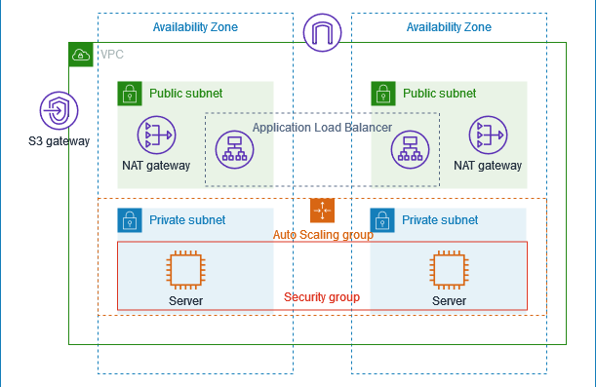

**Overview:**

* The VPC has public and private subnets in two Availability zones.
* Each public subnet has a NAT gateway and a load balancer.
* The servers run in the private subnets are launched and terminated using an Auto scaling group and receive traffic from the load balancer.
* The servers can connect to the internet using the NAt gateway

**STEPS:**

1.Select a VPC from the AWS services.

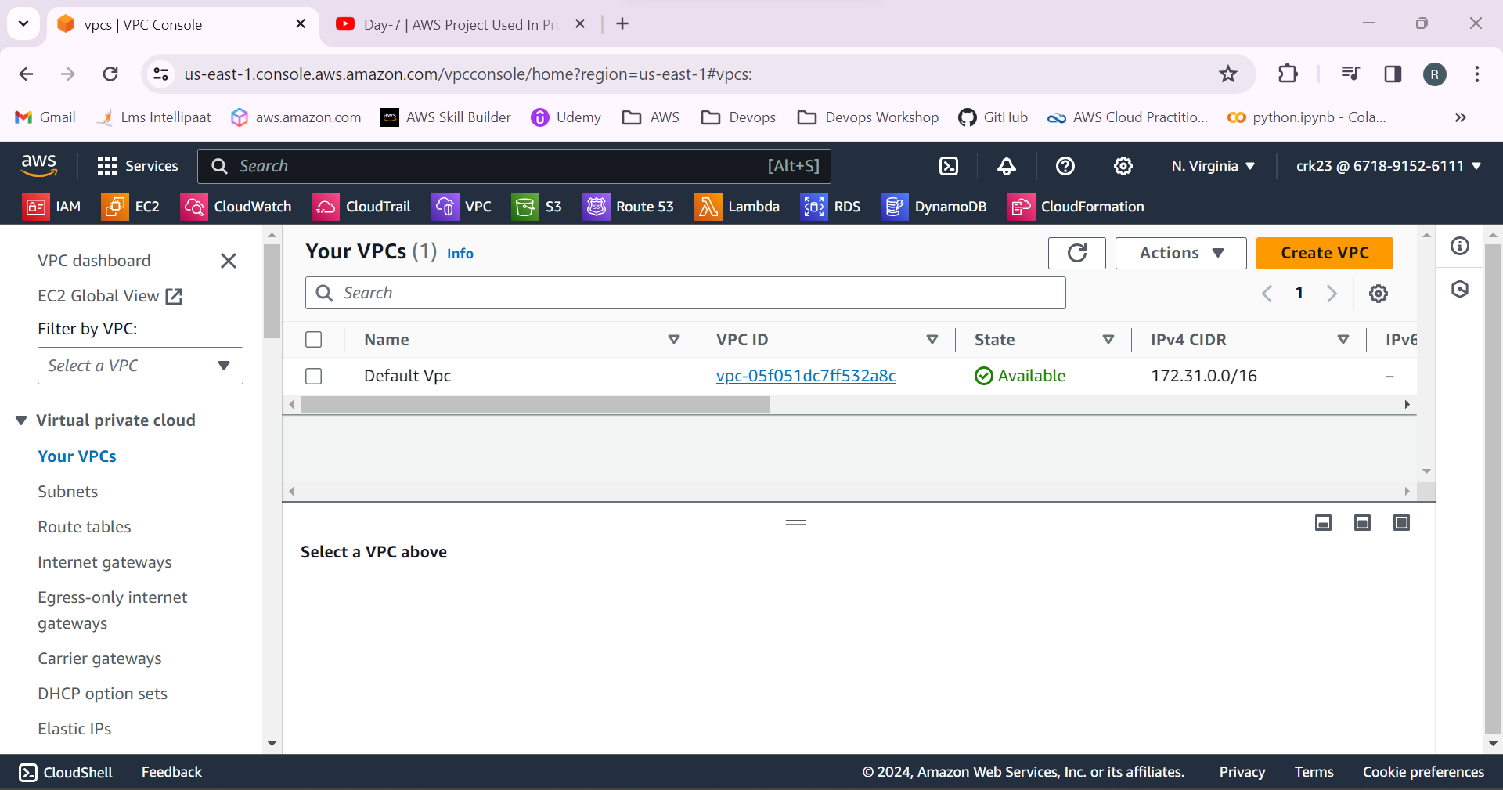

2.Create a VPC with CIDR range 10.0.0.0/24.

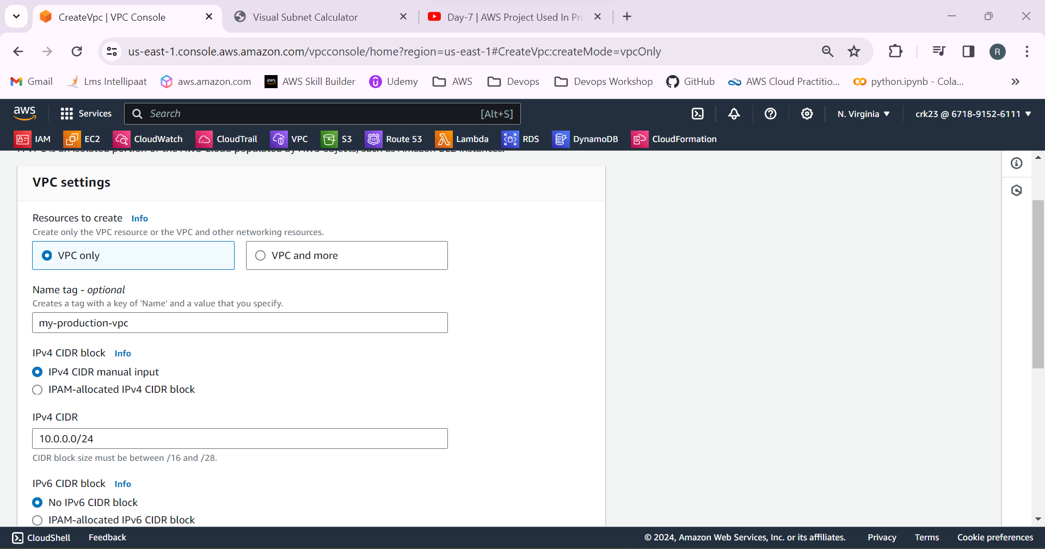

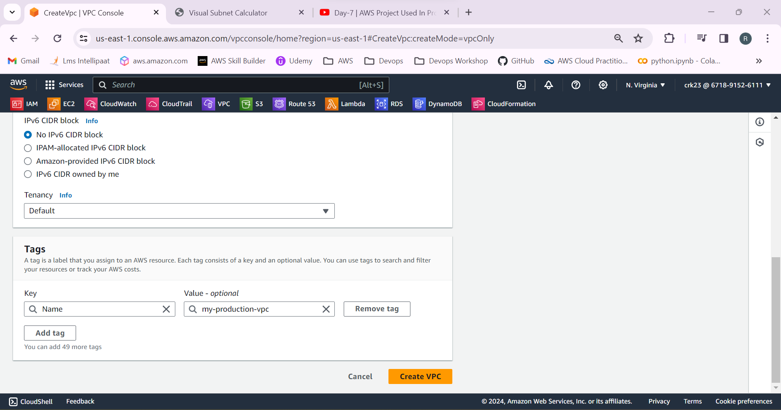

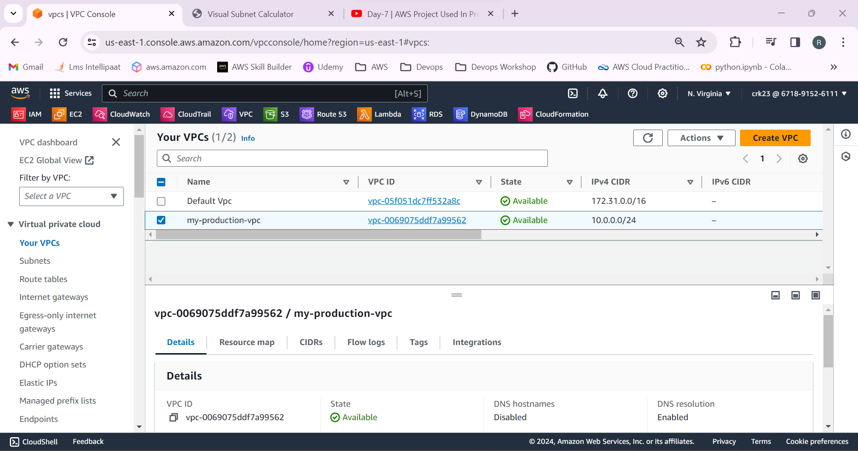

3.Select subnet and create 4 subnets in the name public subnet 1 & 2 , private subnet 1 & 2 in us-east-1a & us-east-1b.

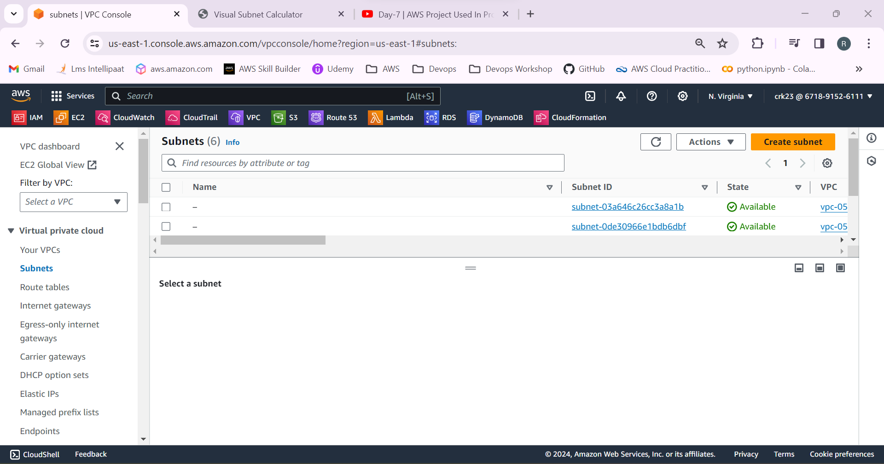

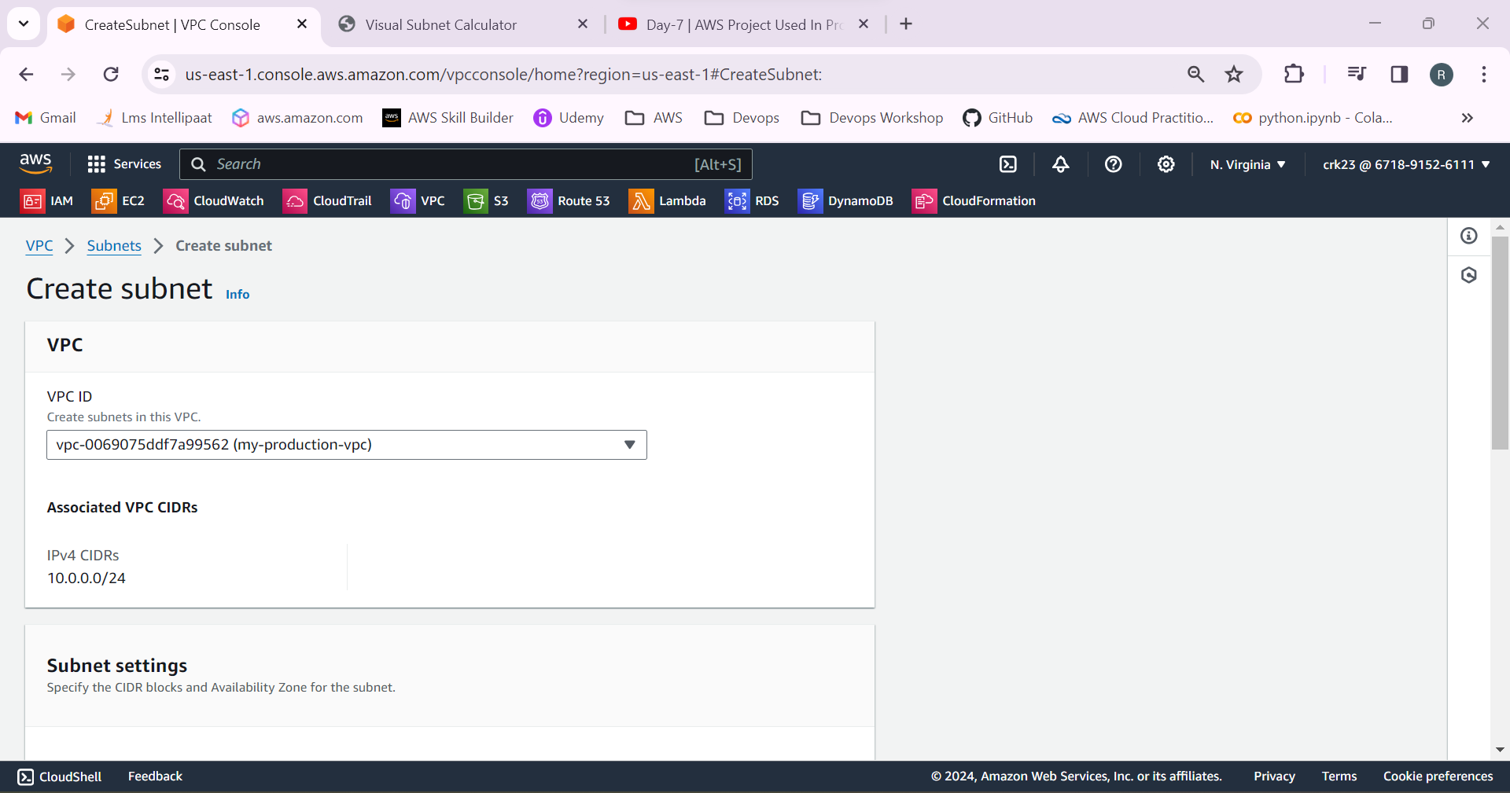

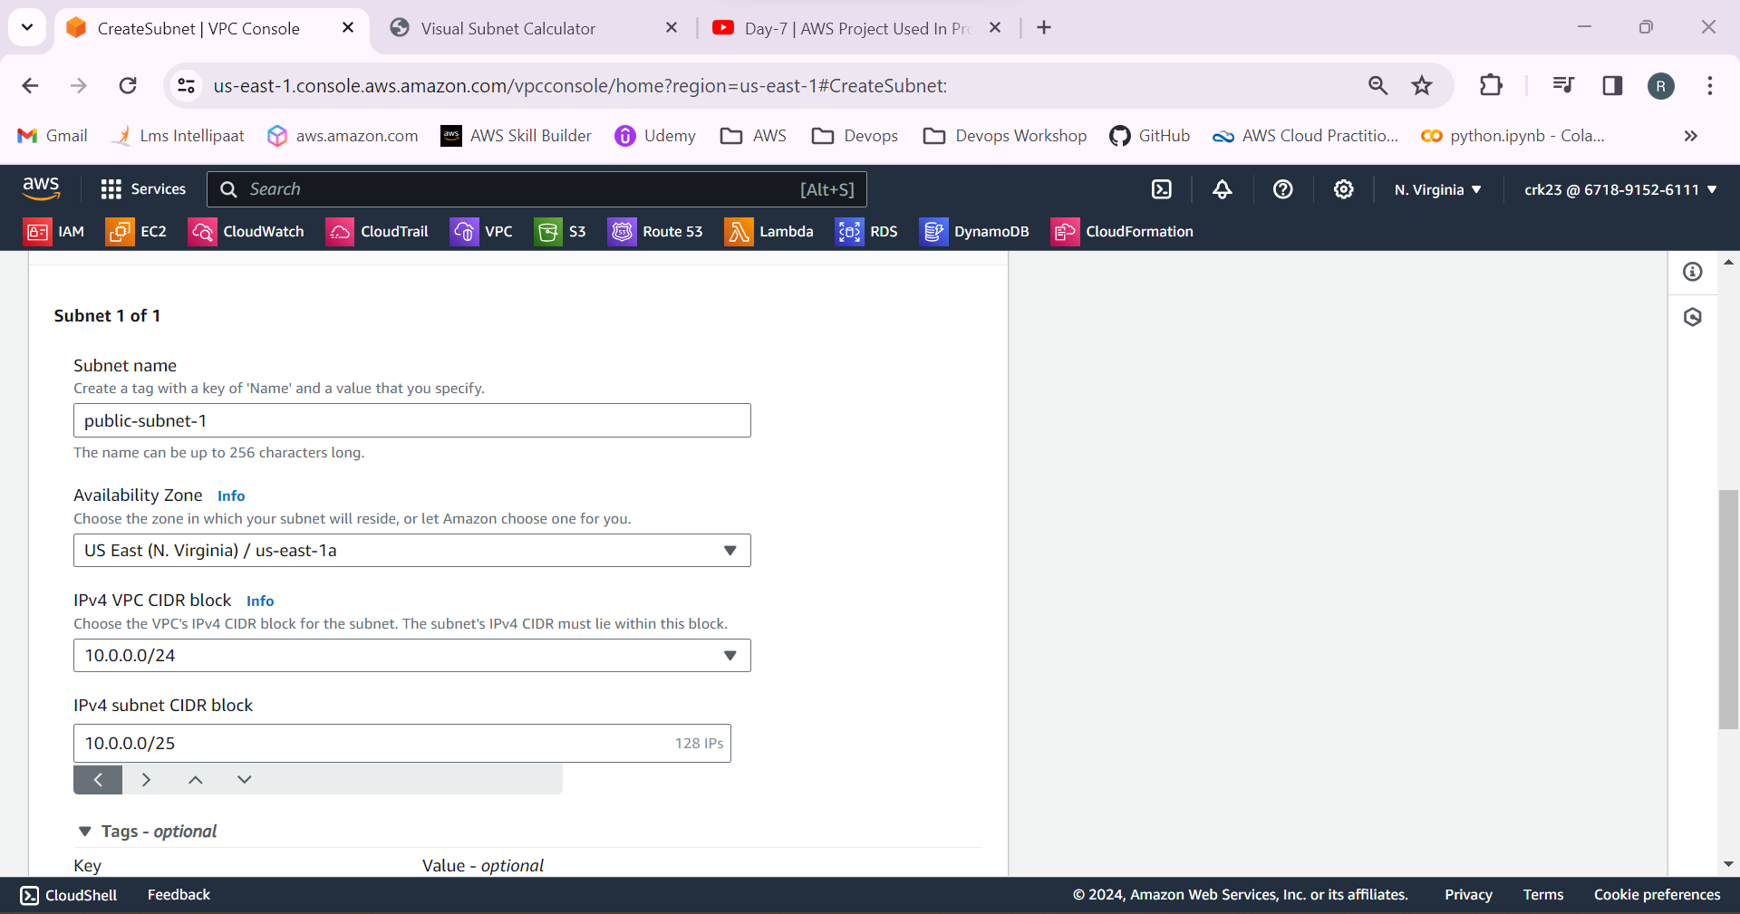

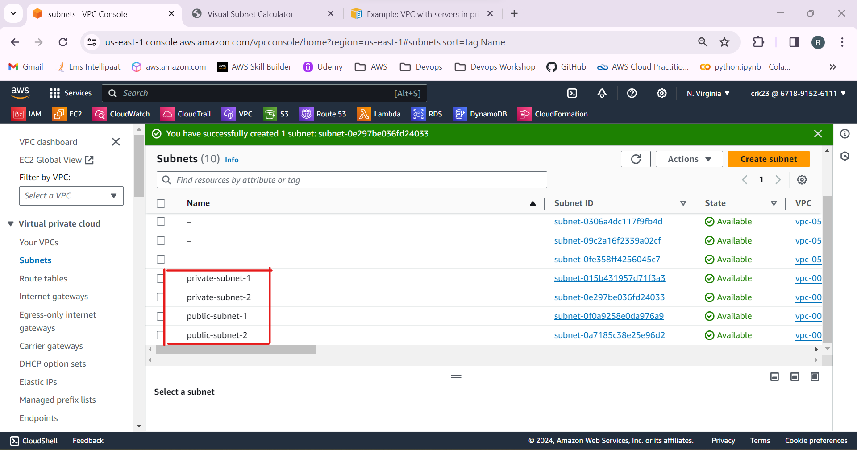

4.Select Route table and create 3 route tables

* Private route table
* Public route table
* Public route table

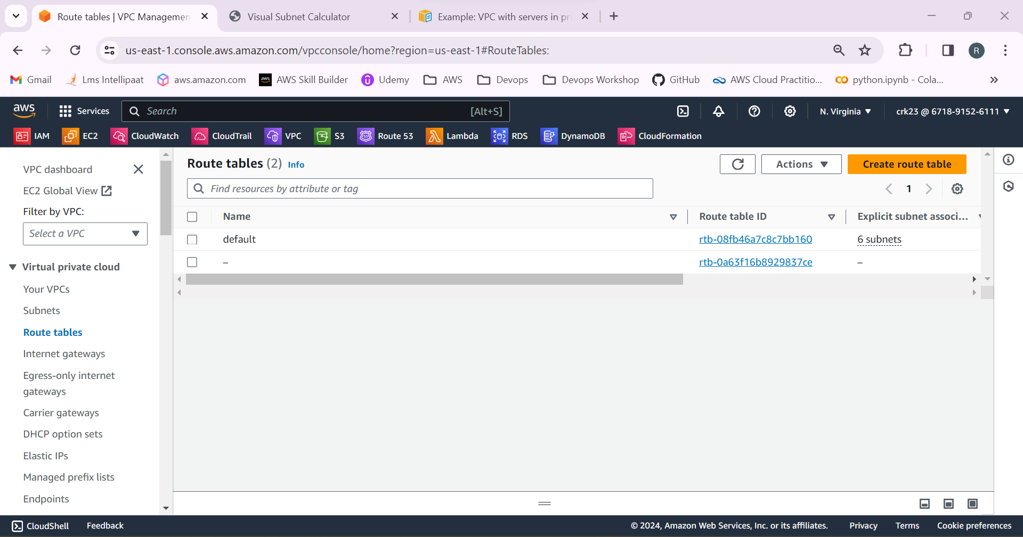

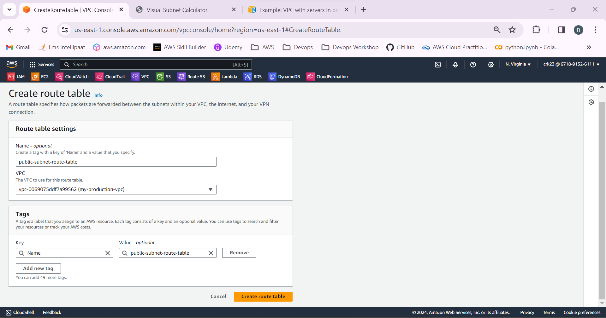

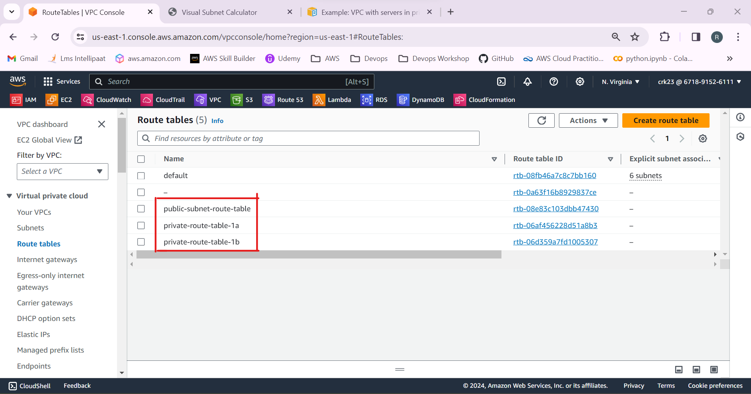

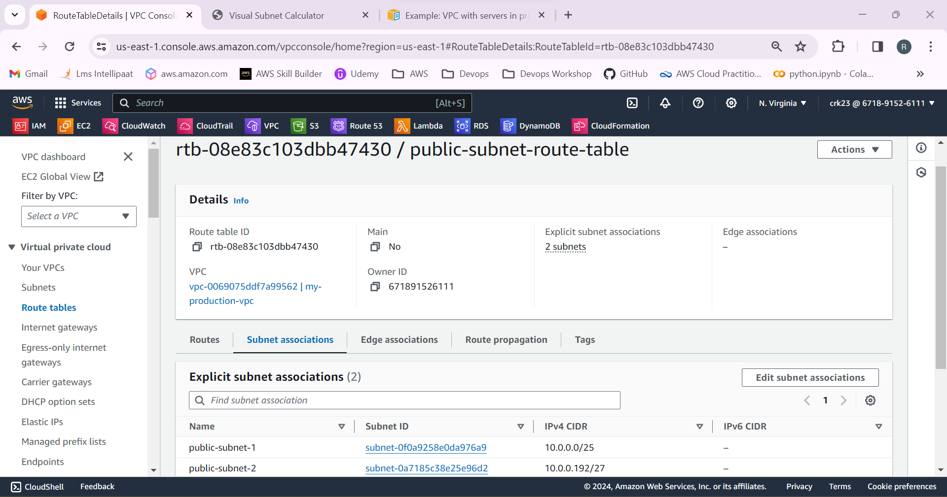

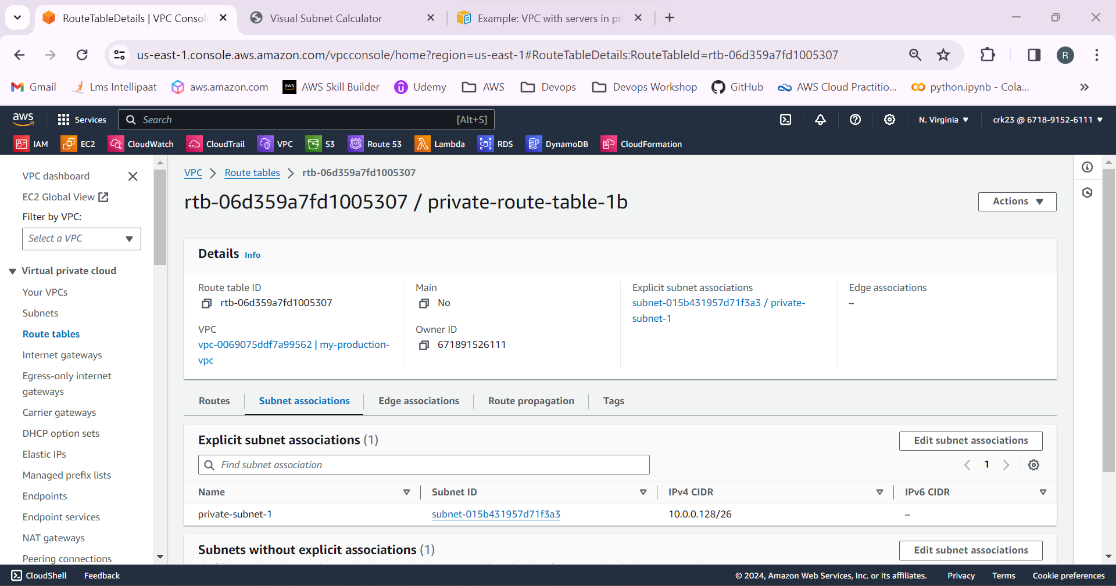

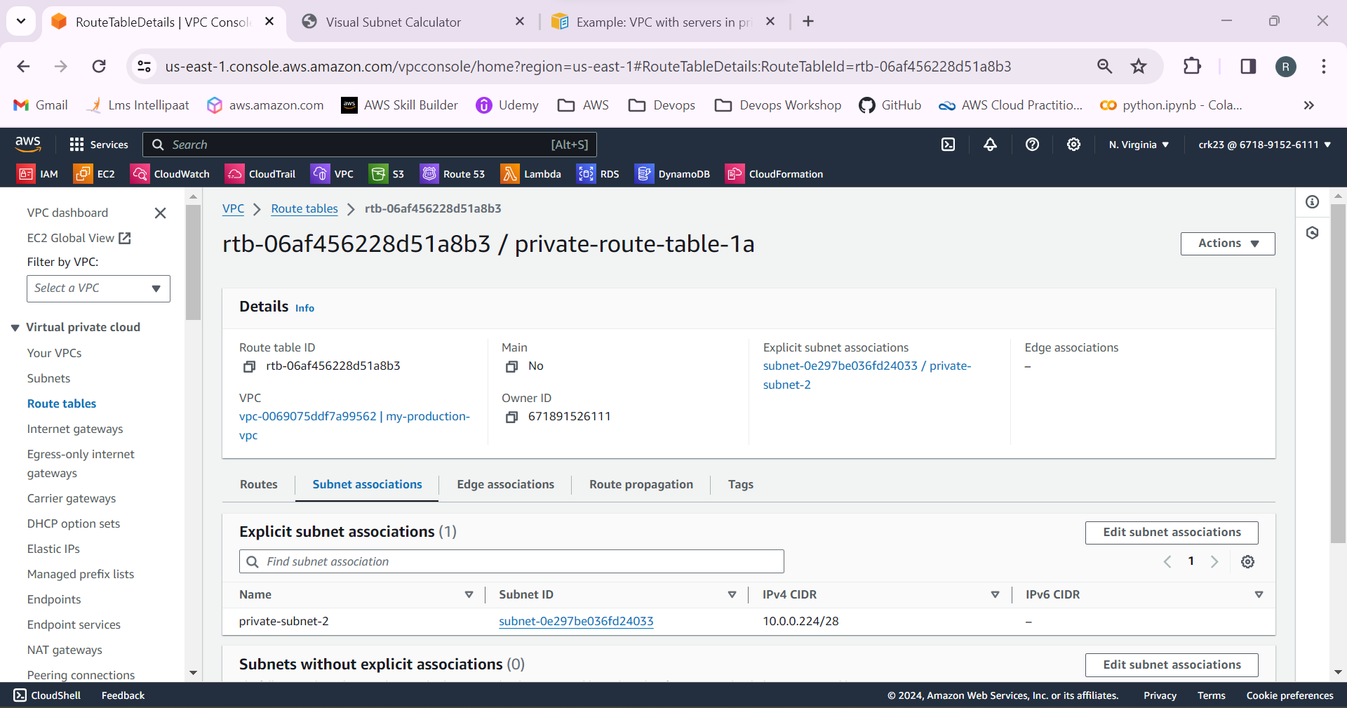

5.Select internet gateway and create a internet gateway and attach it to the created VPC.

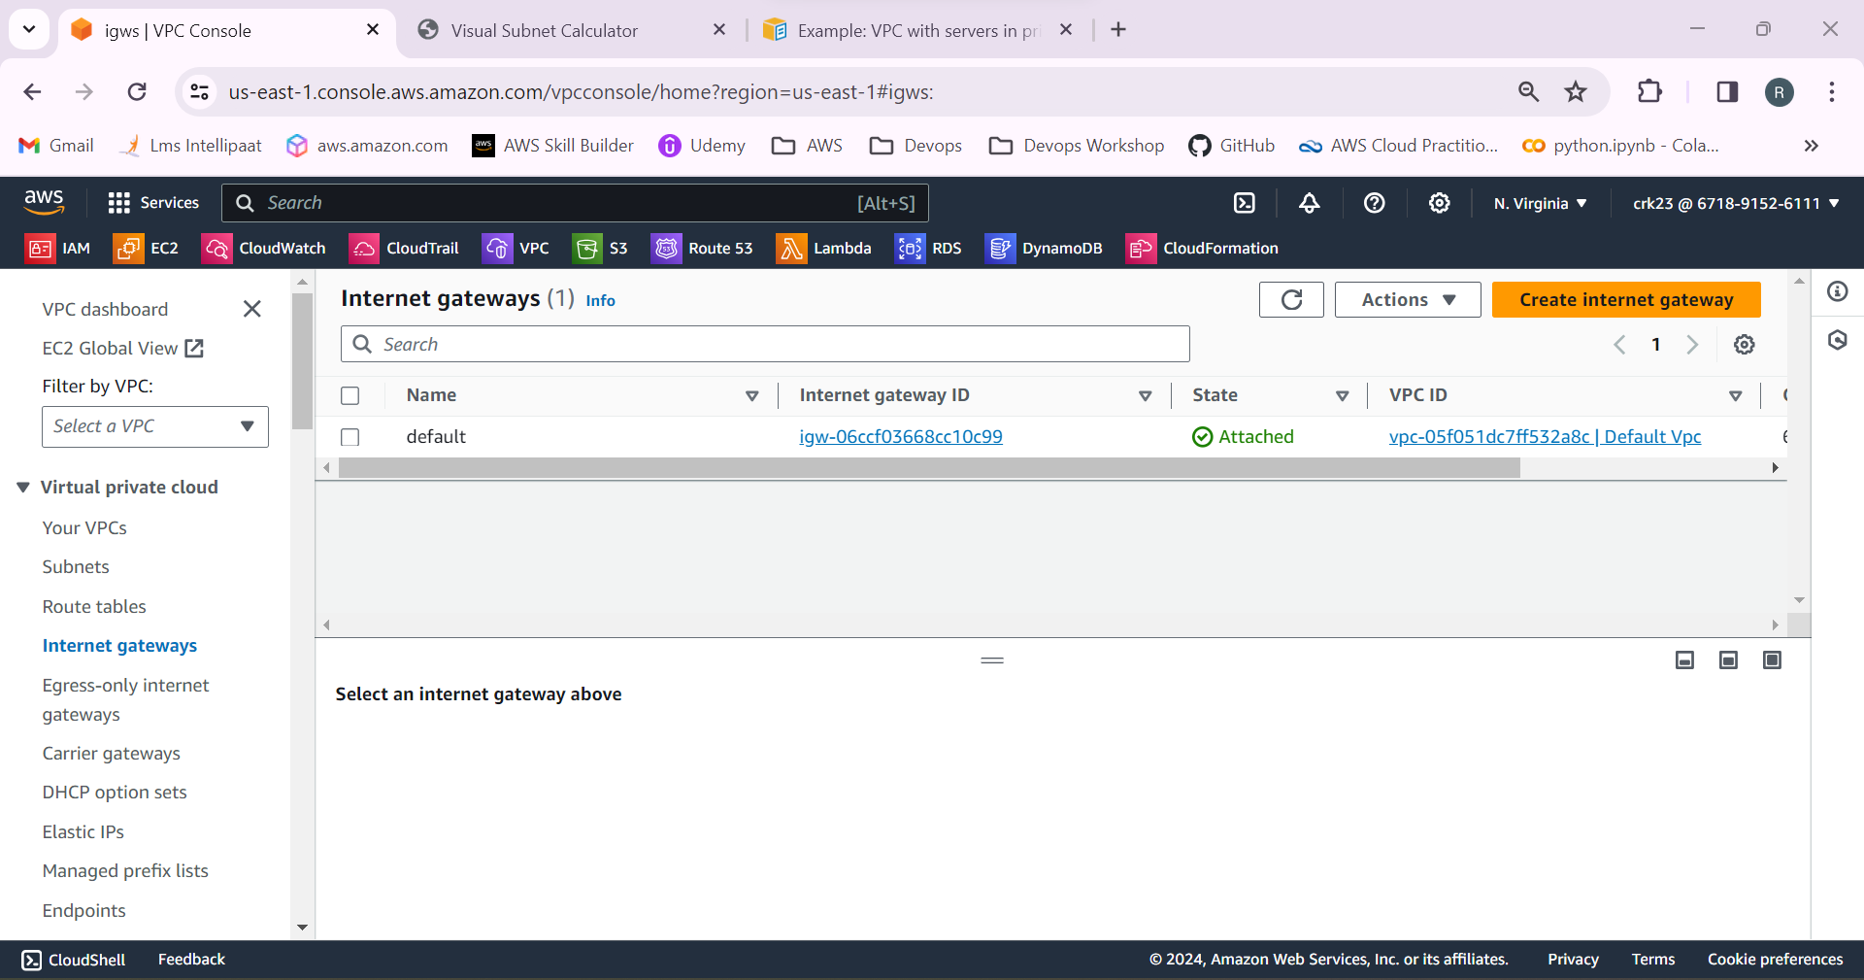

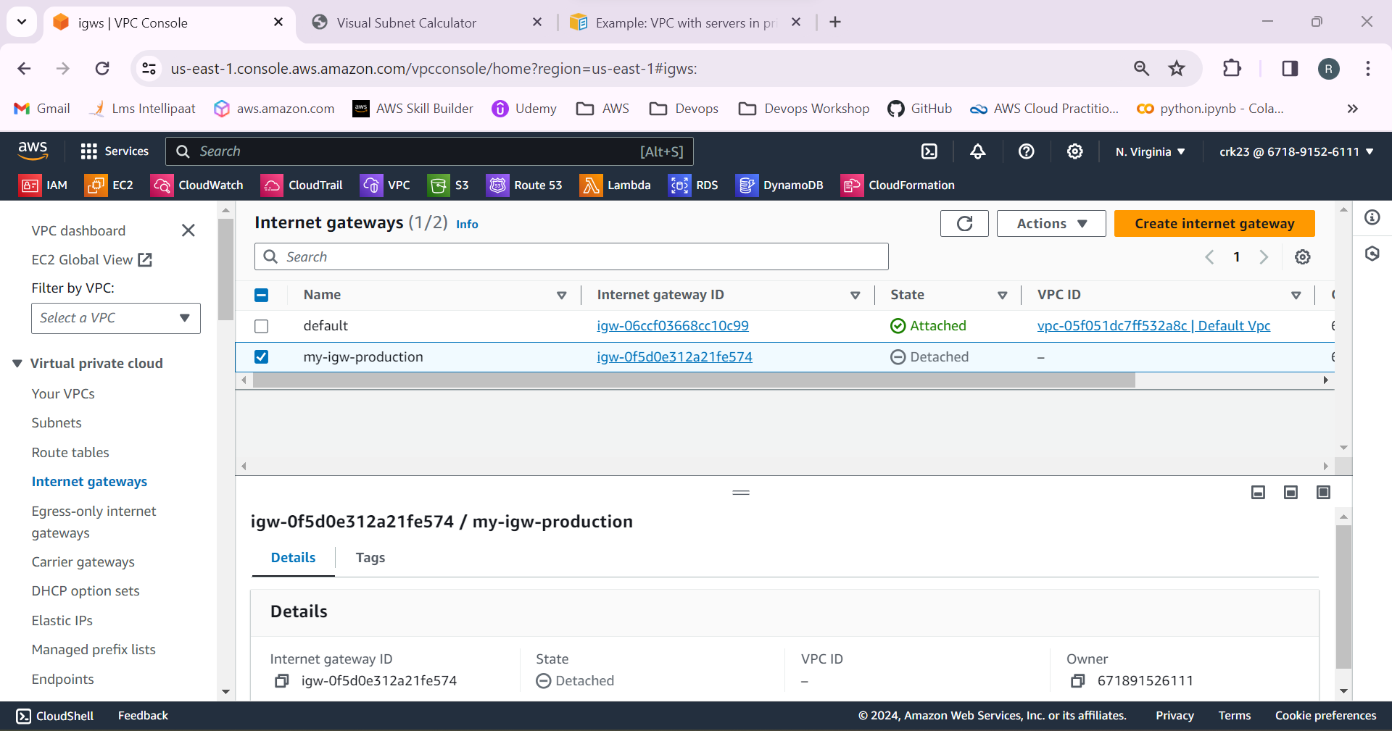

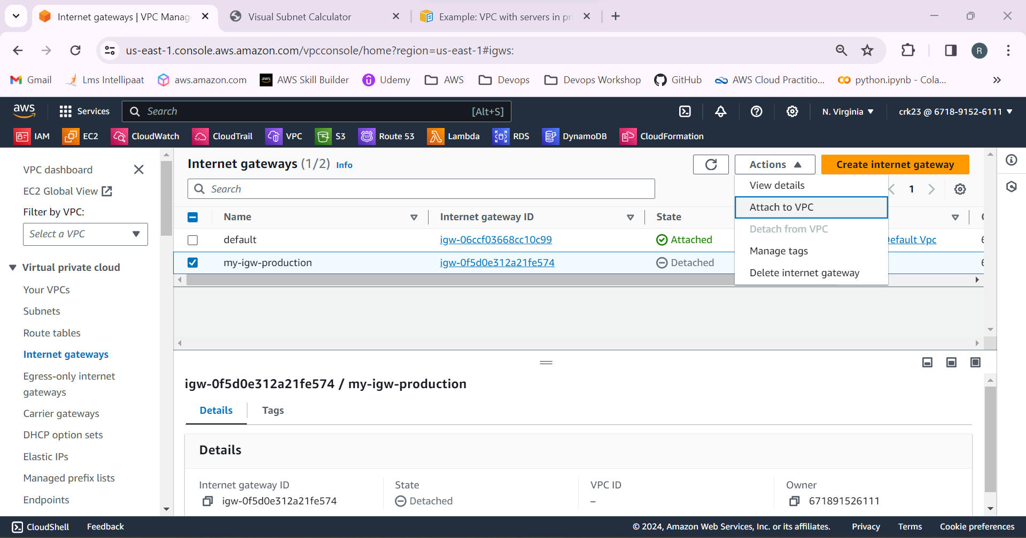

6.Select NAT gateways and create two NAT gateway in private subnet 1 & 2.

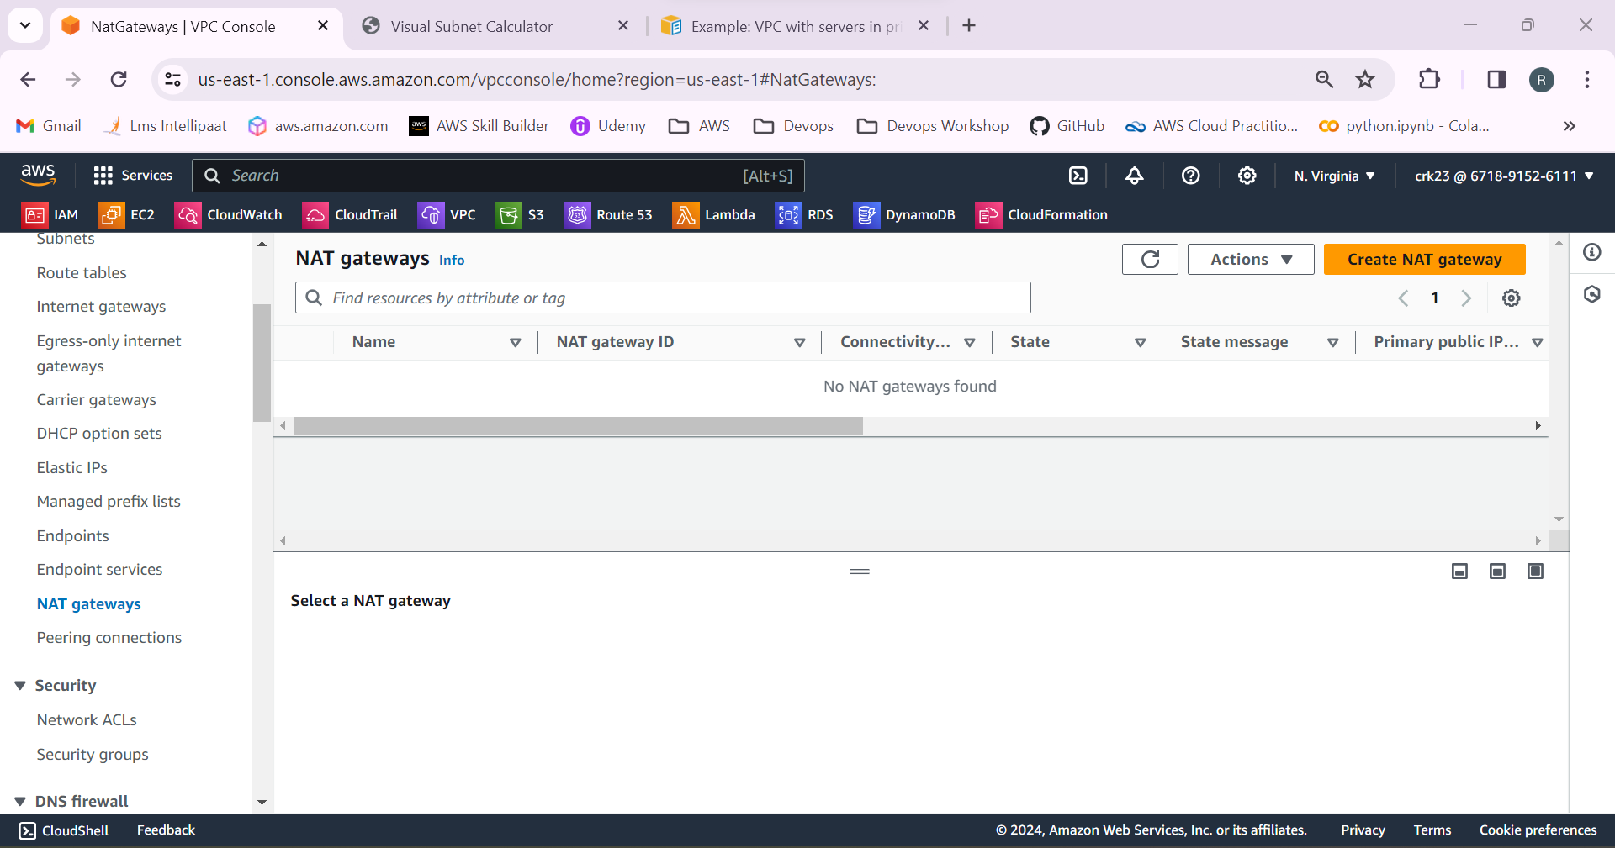

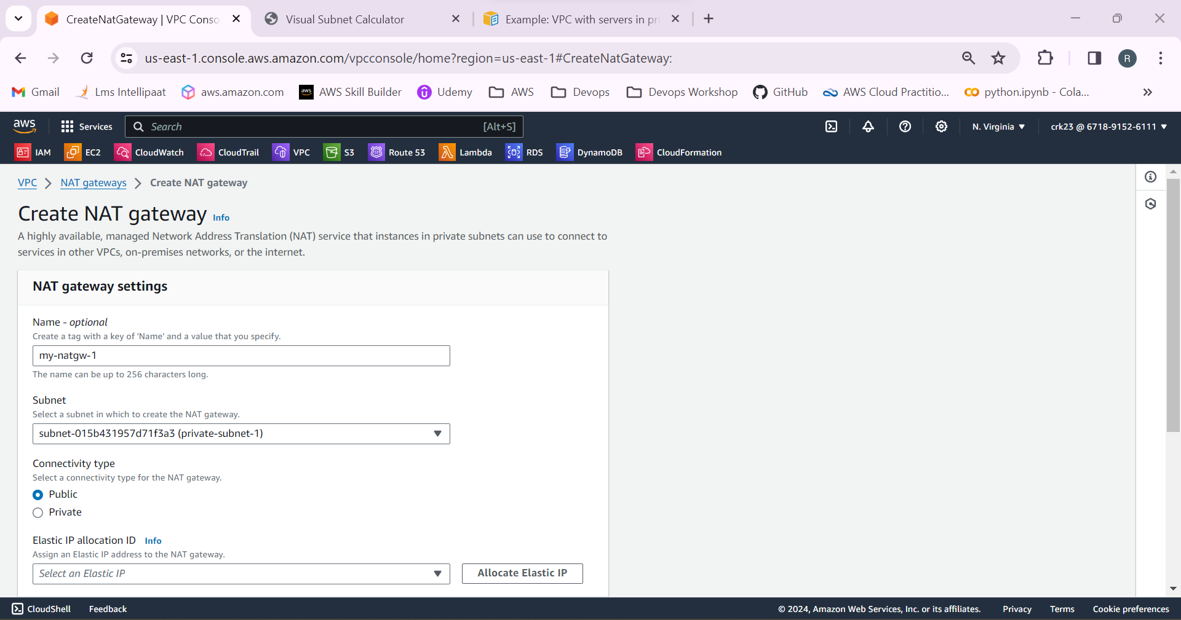

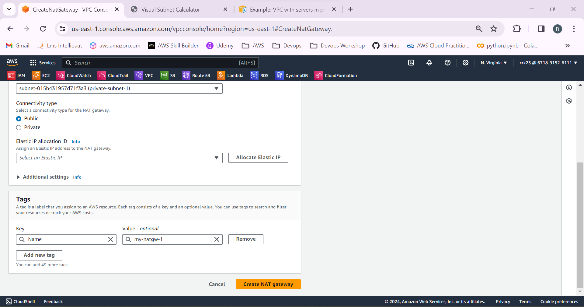

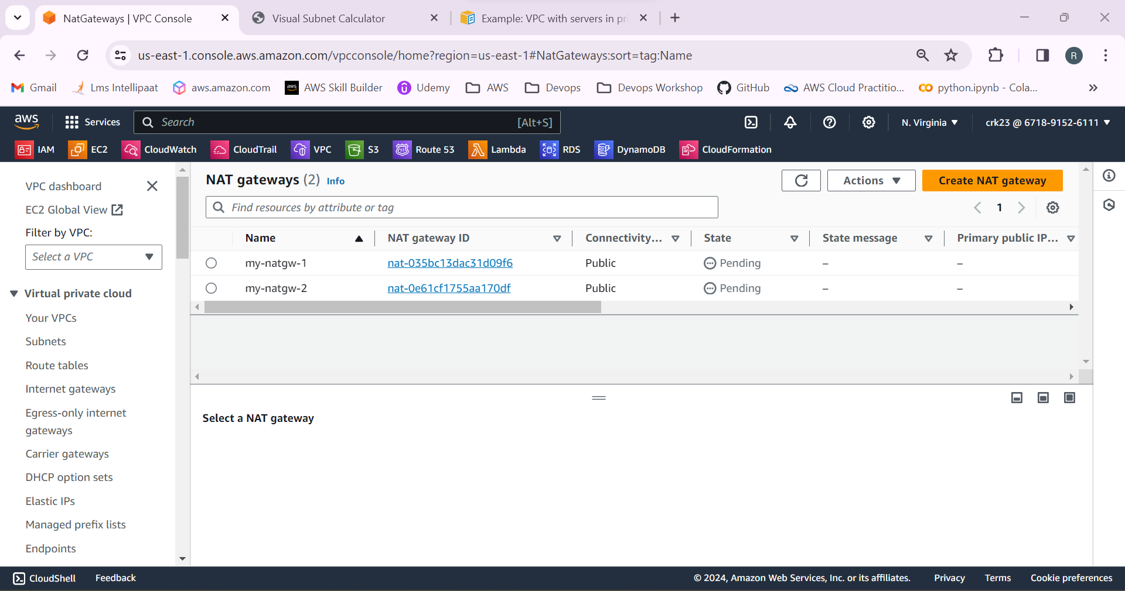

7.Select the route table, In public route table add the target as internet gateway.

In private route table 1 & 2 add the target as NAT gateway.

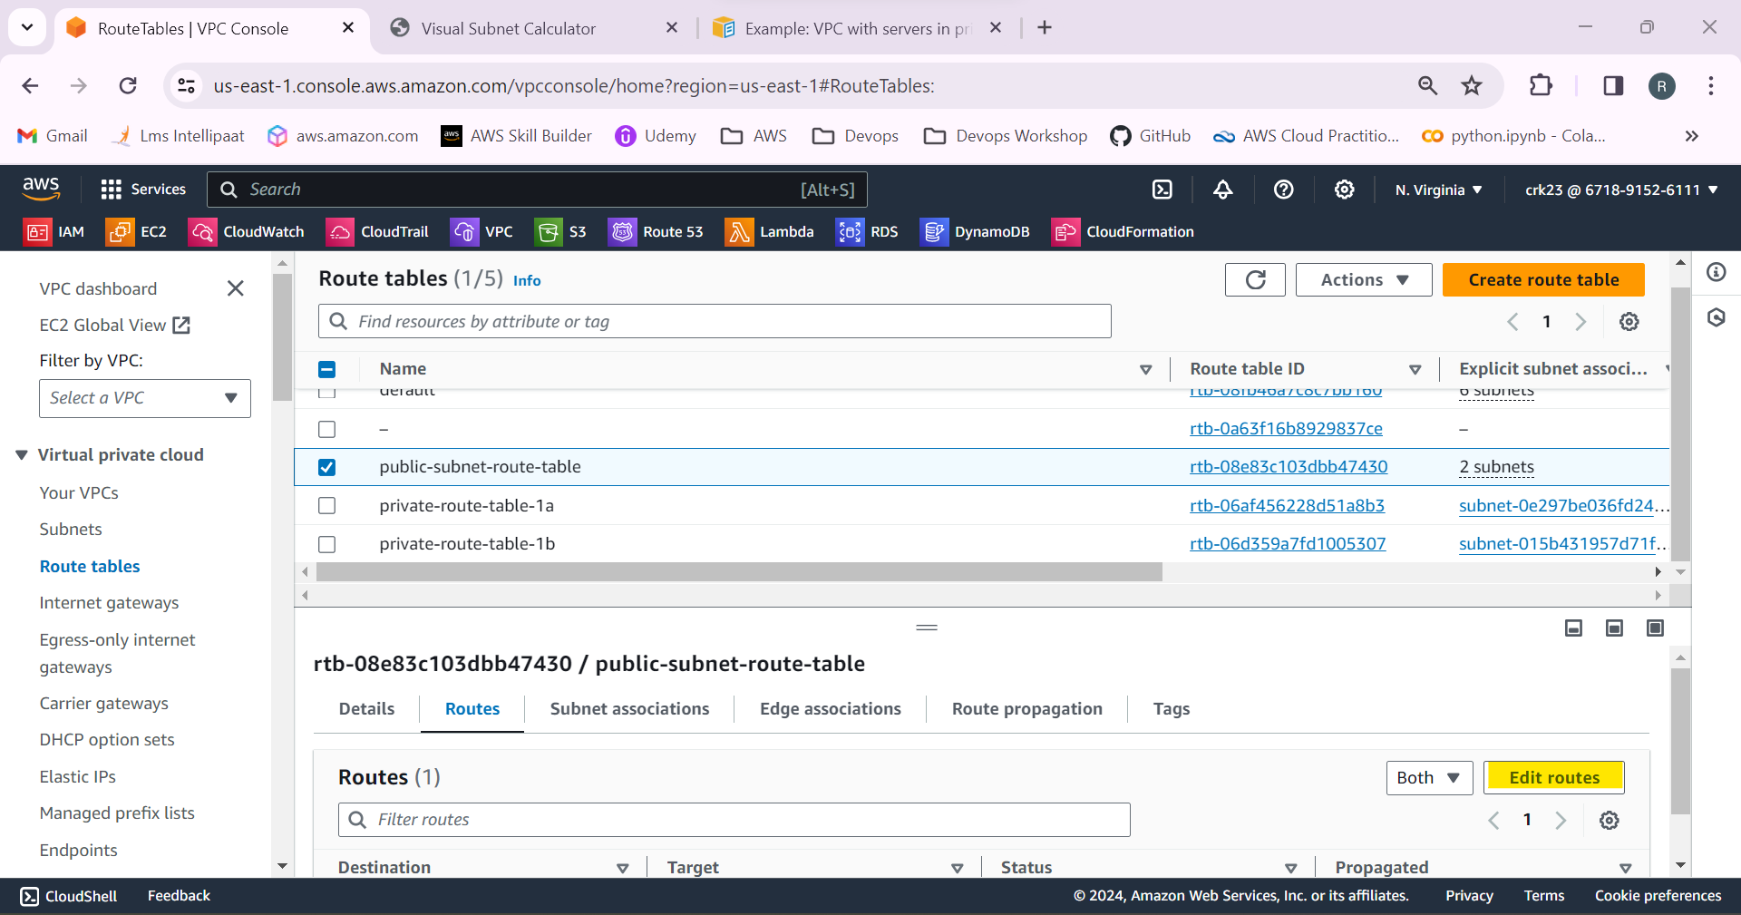

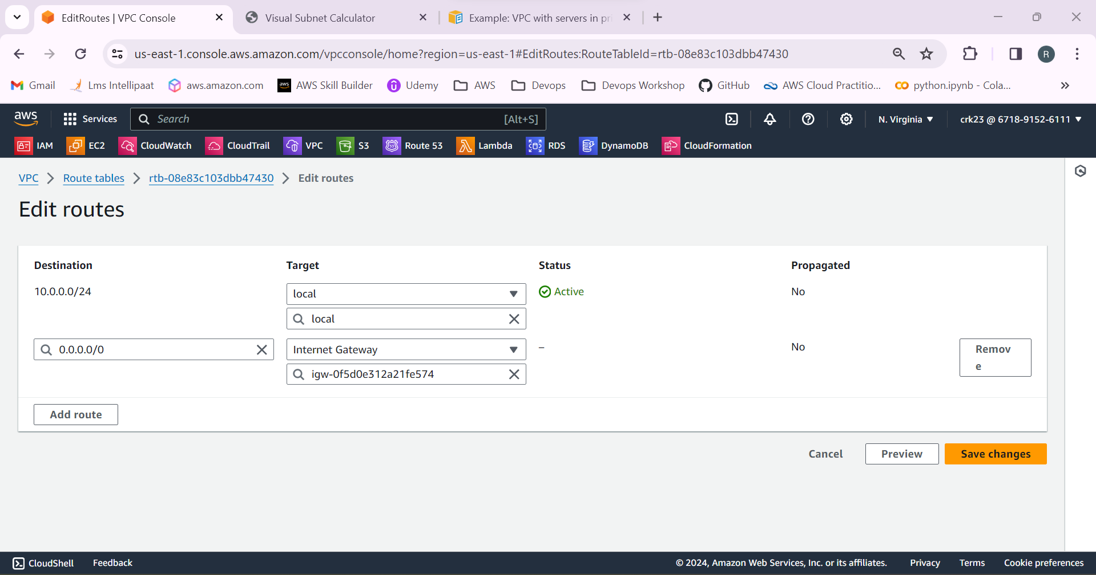

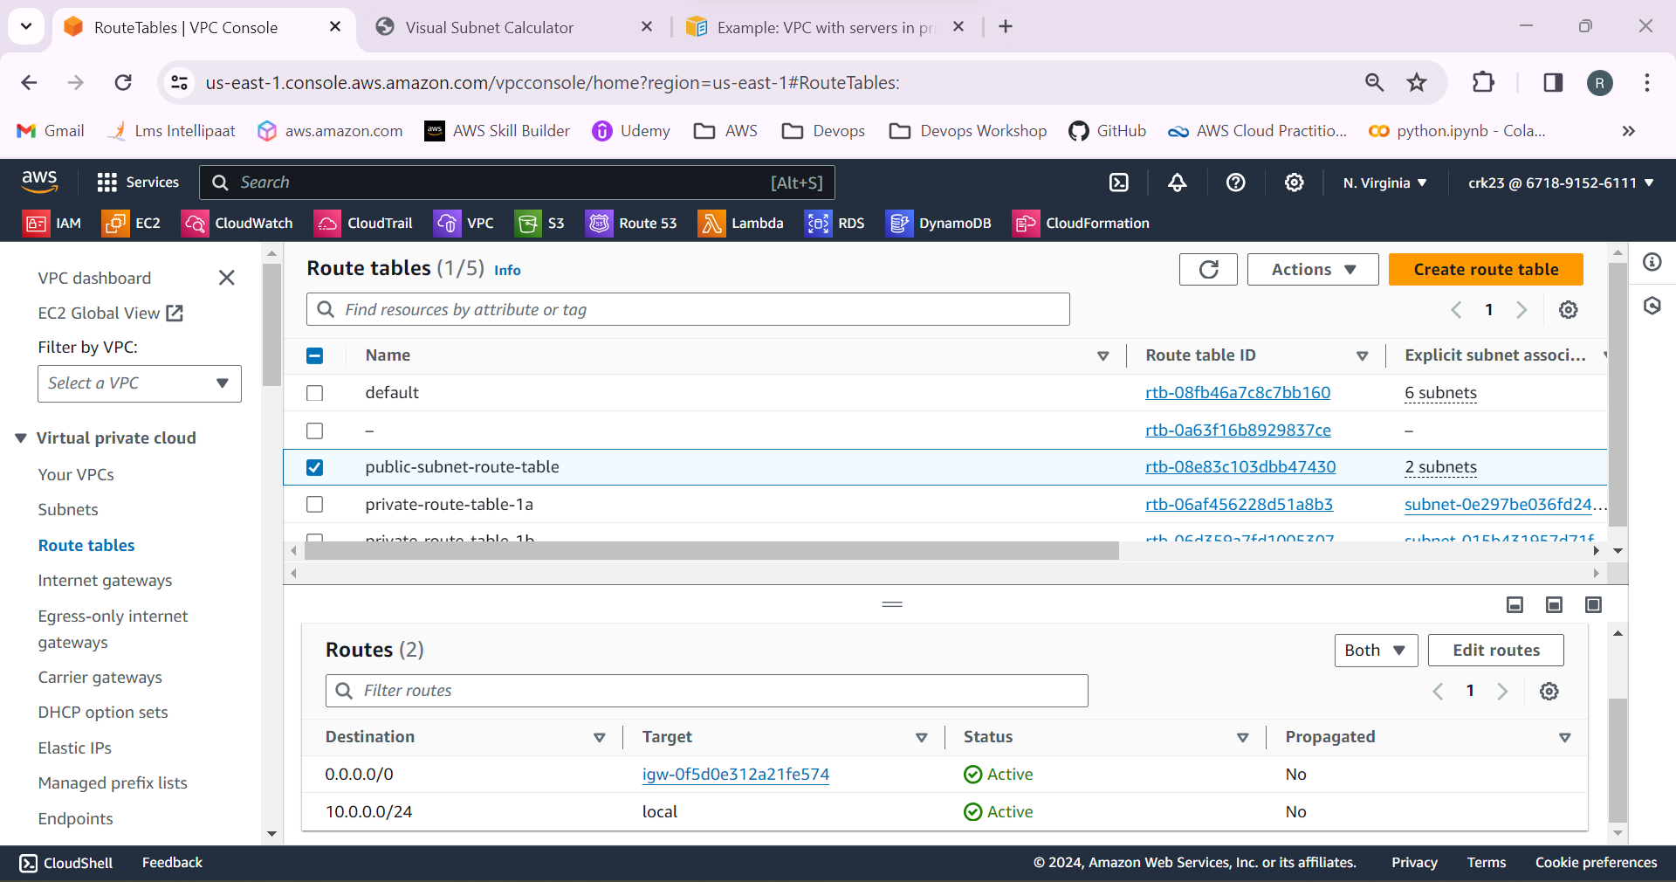

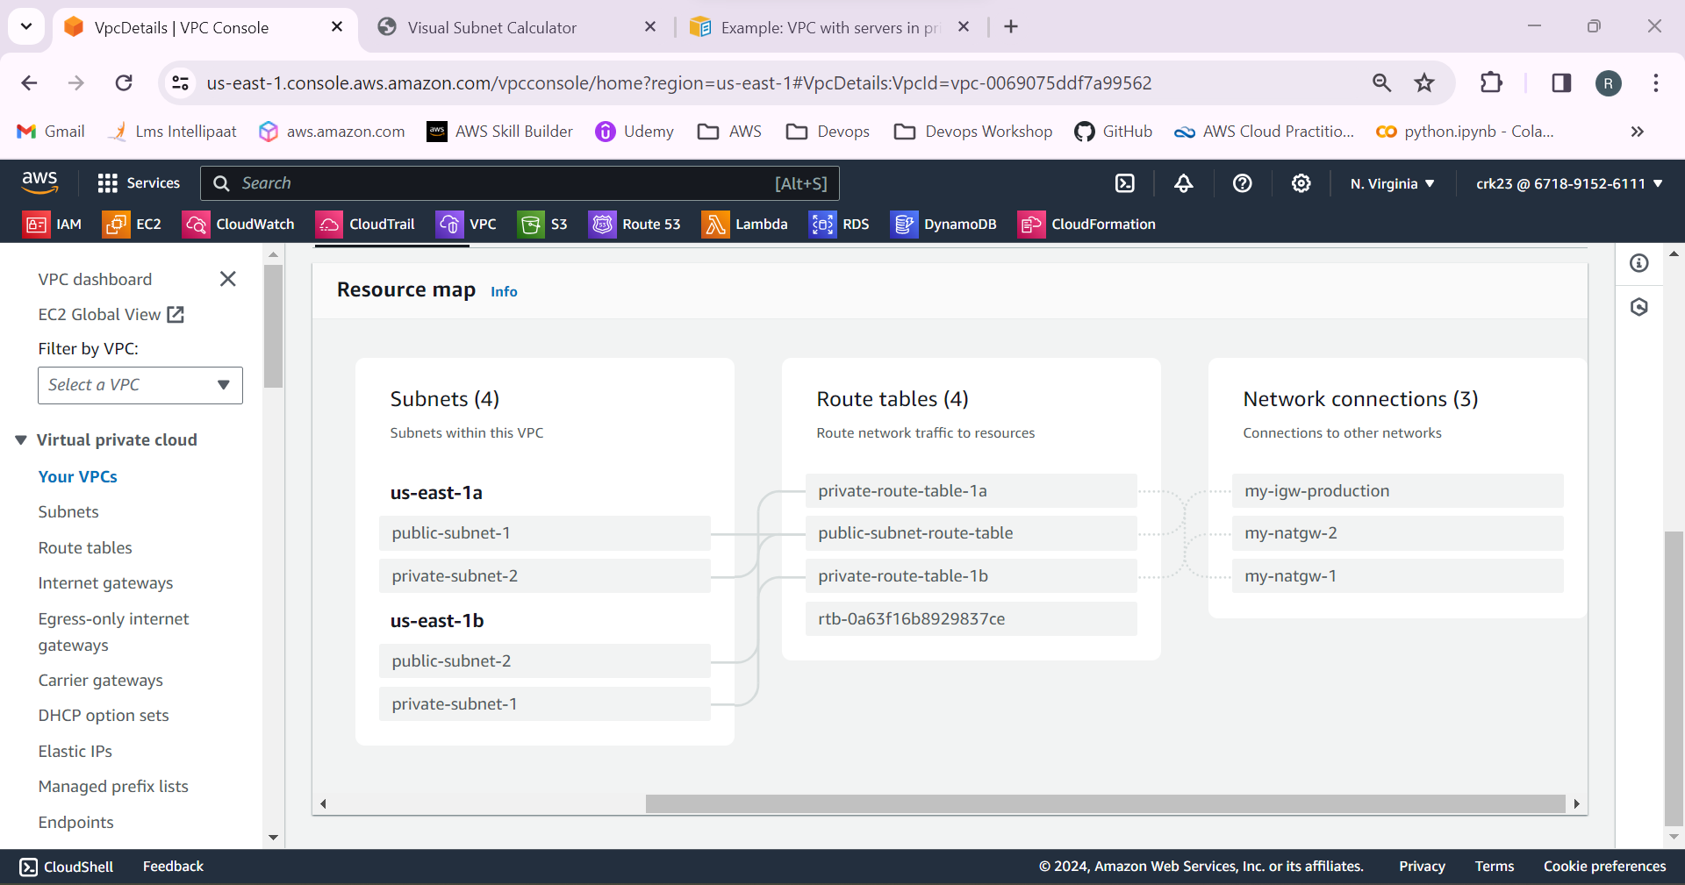

8.Select EC2 from AWS services > Launch templates. Create a launch template

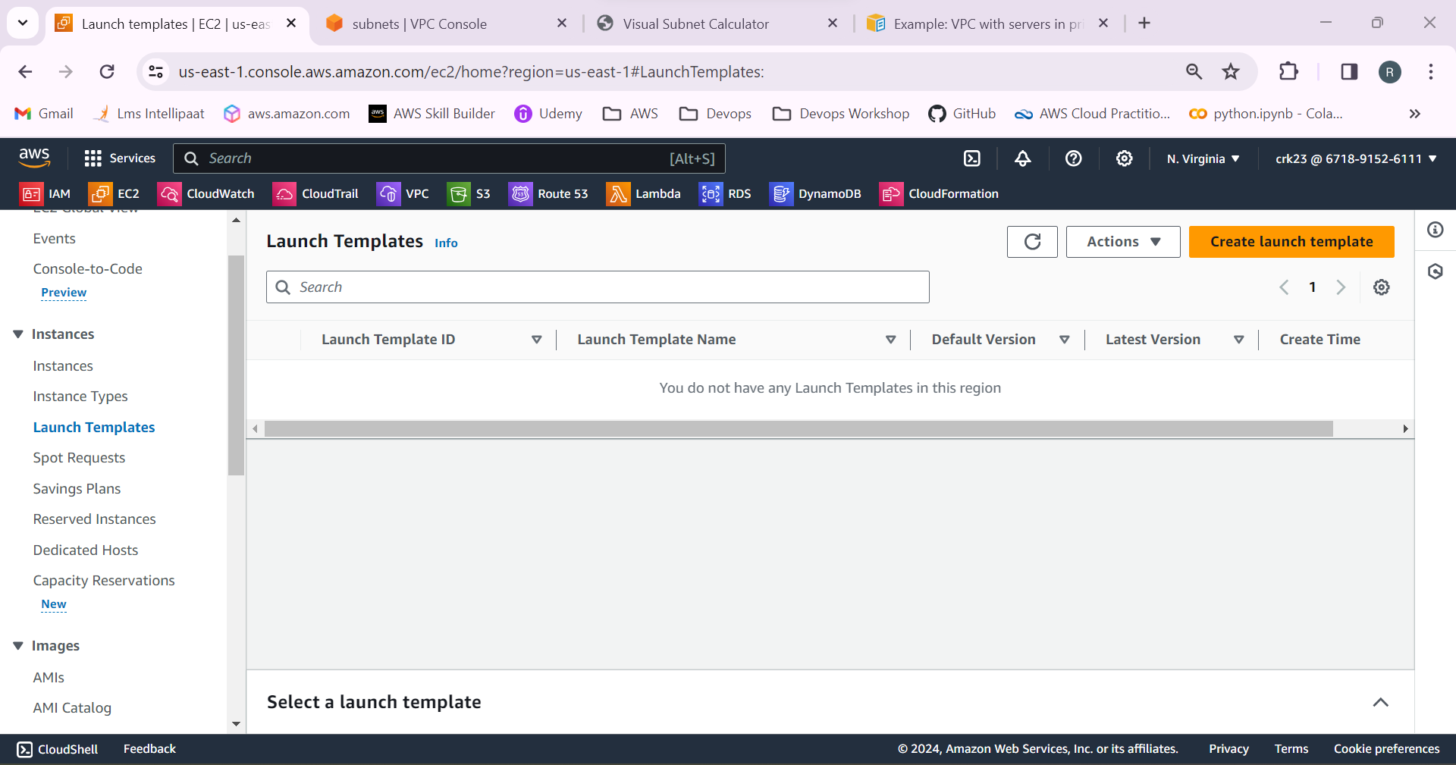

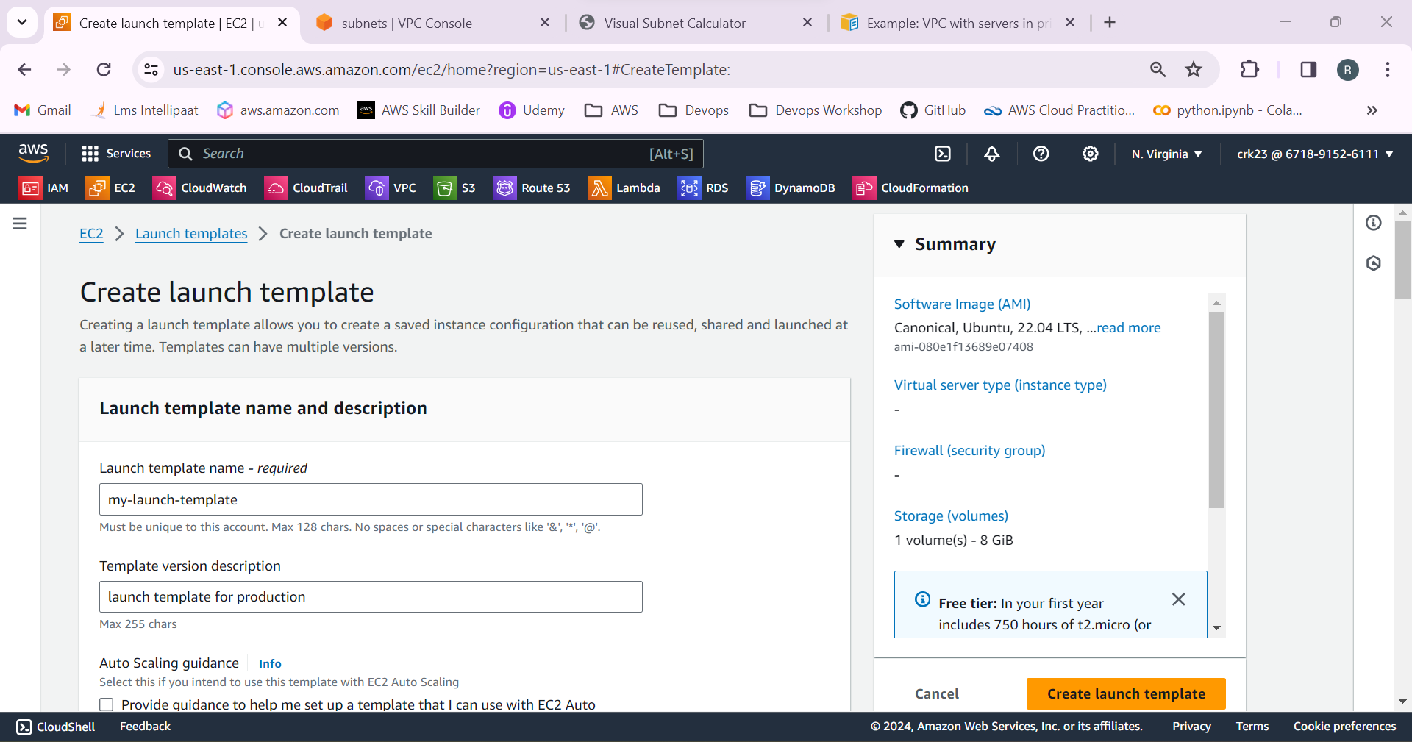

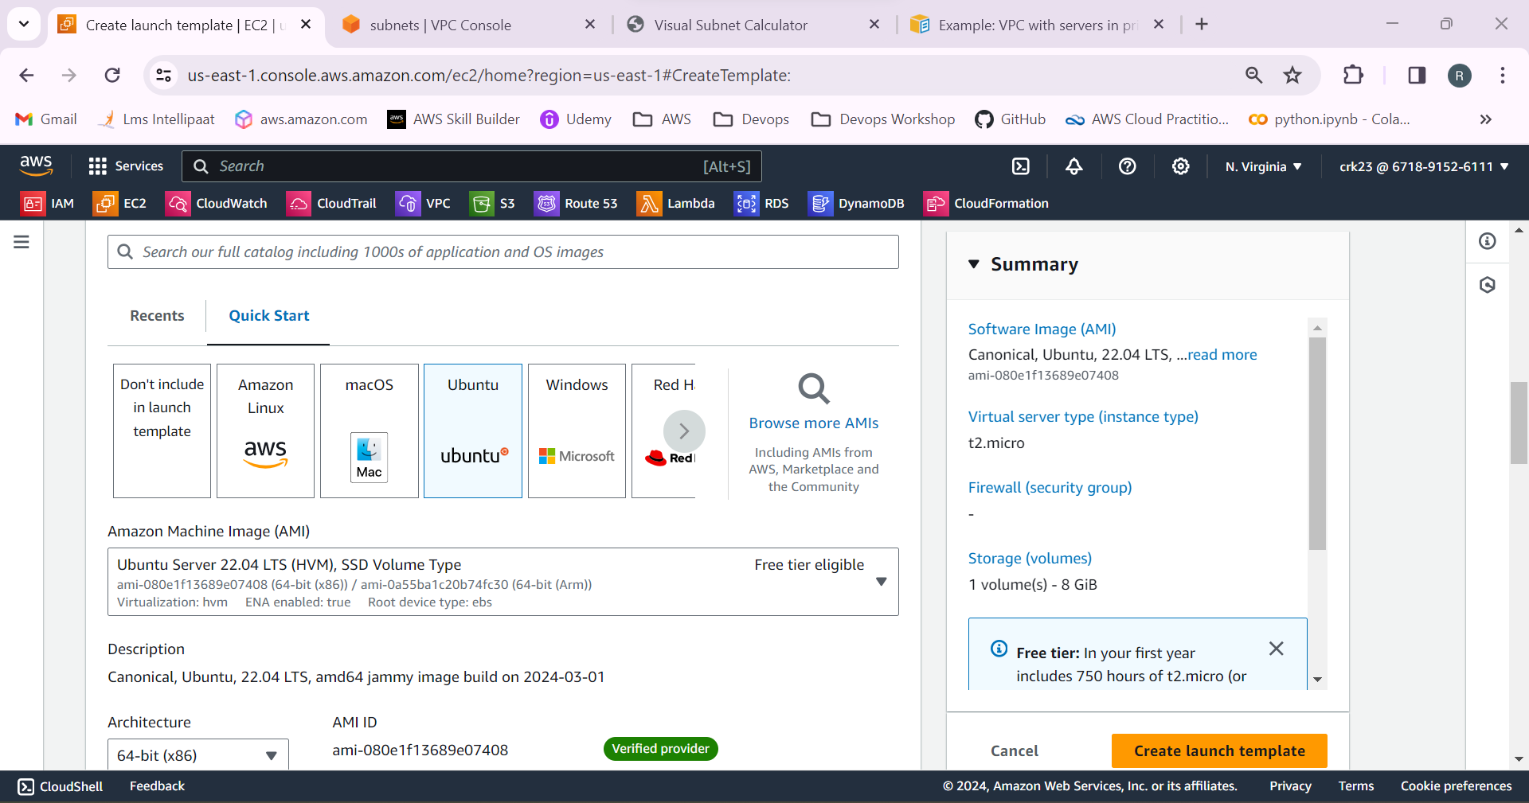

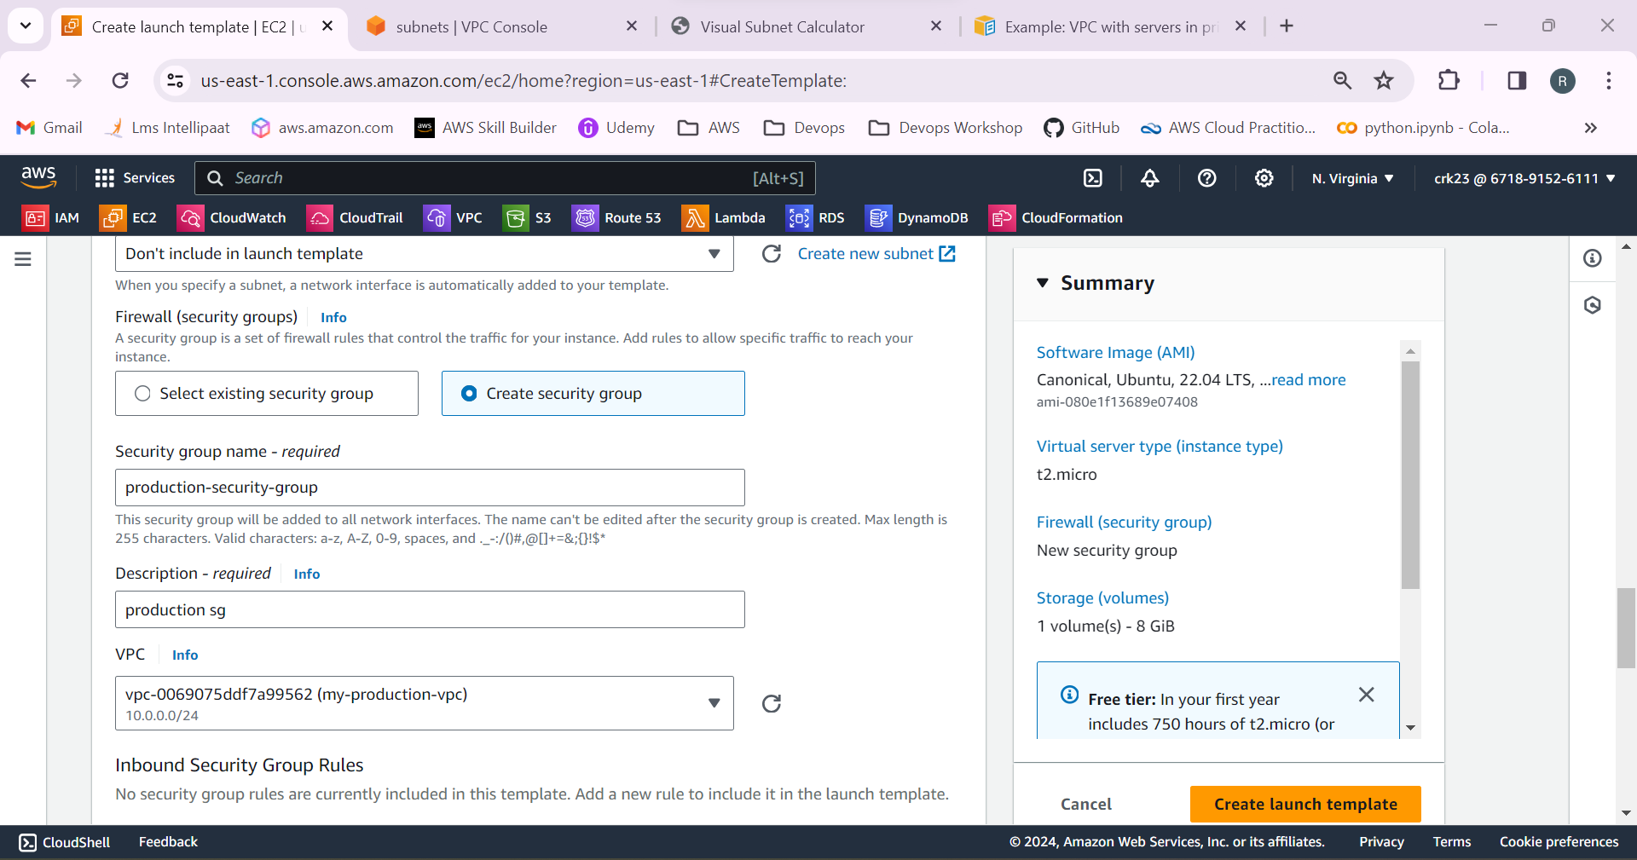

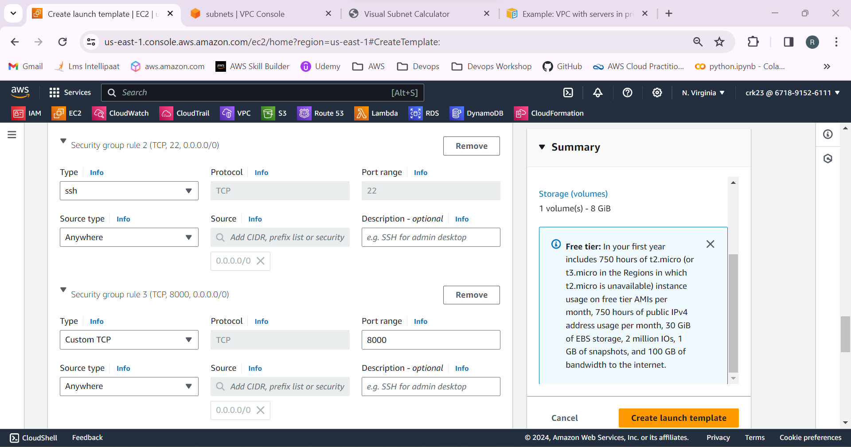

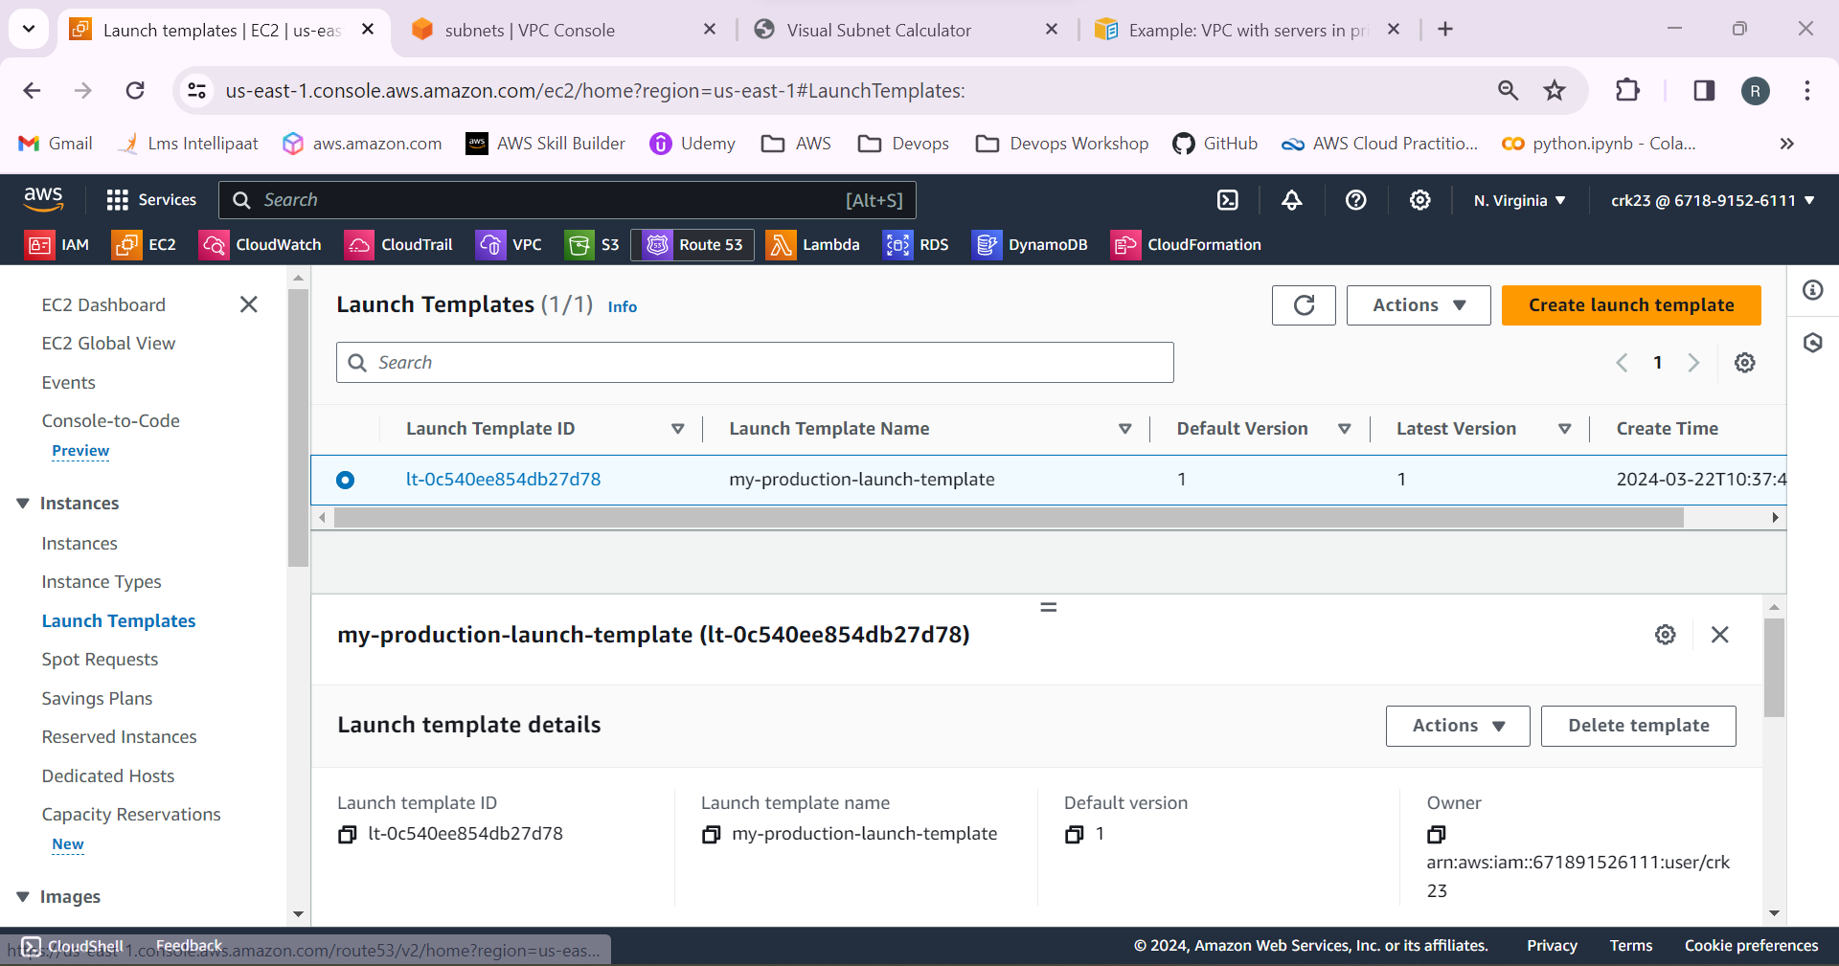

9. Select Auto scaling groups and create ASG with desired capacity as 2, minimum as 1, maximum as 3.

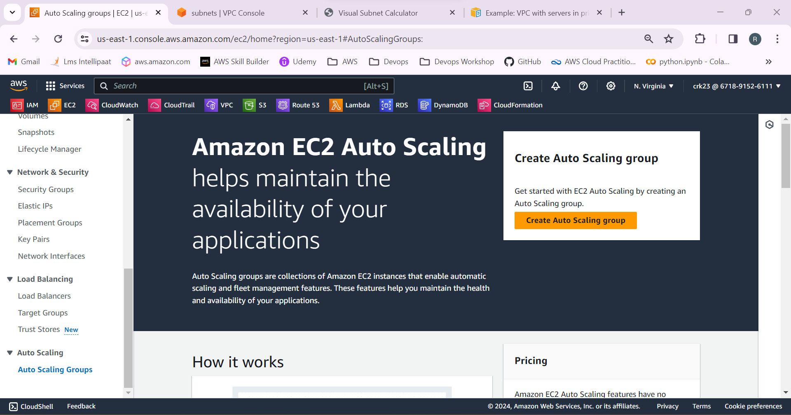

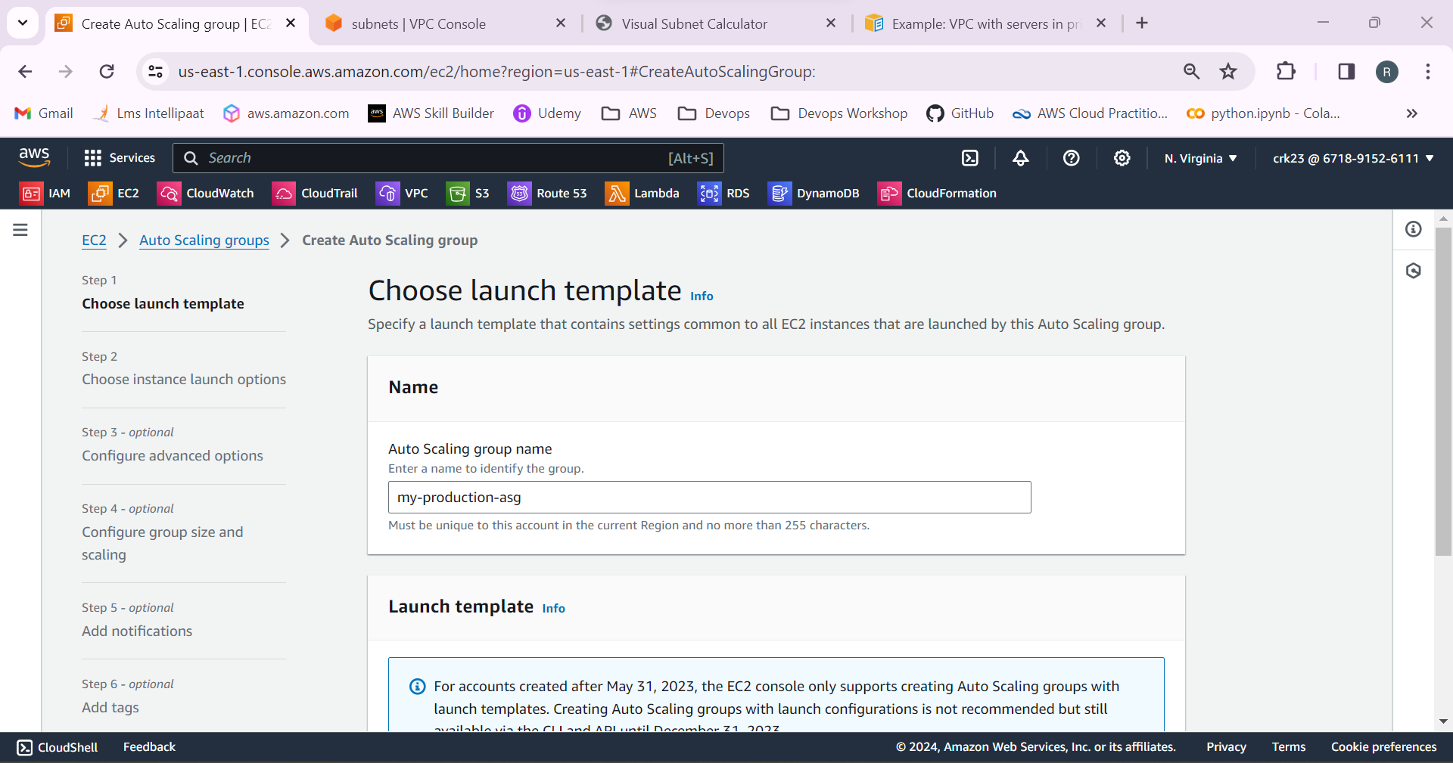

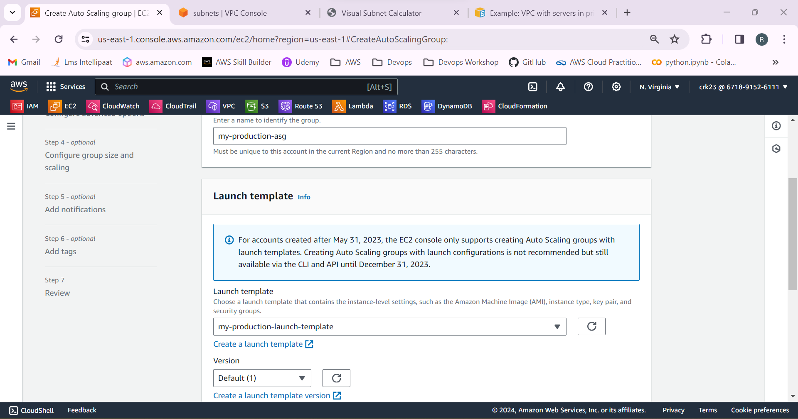

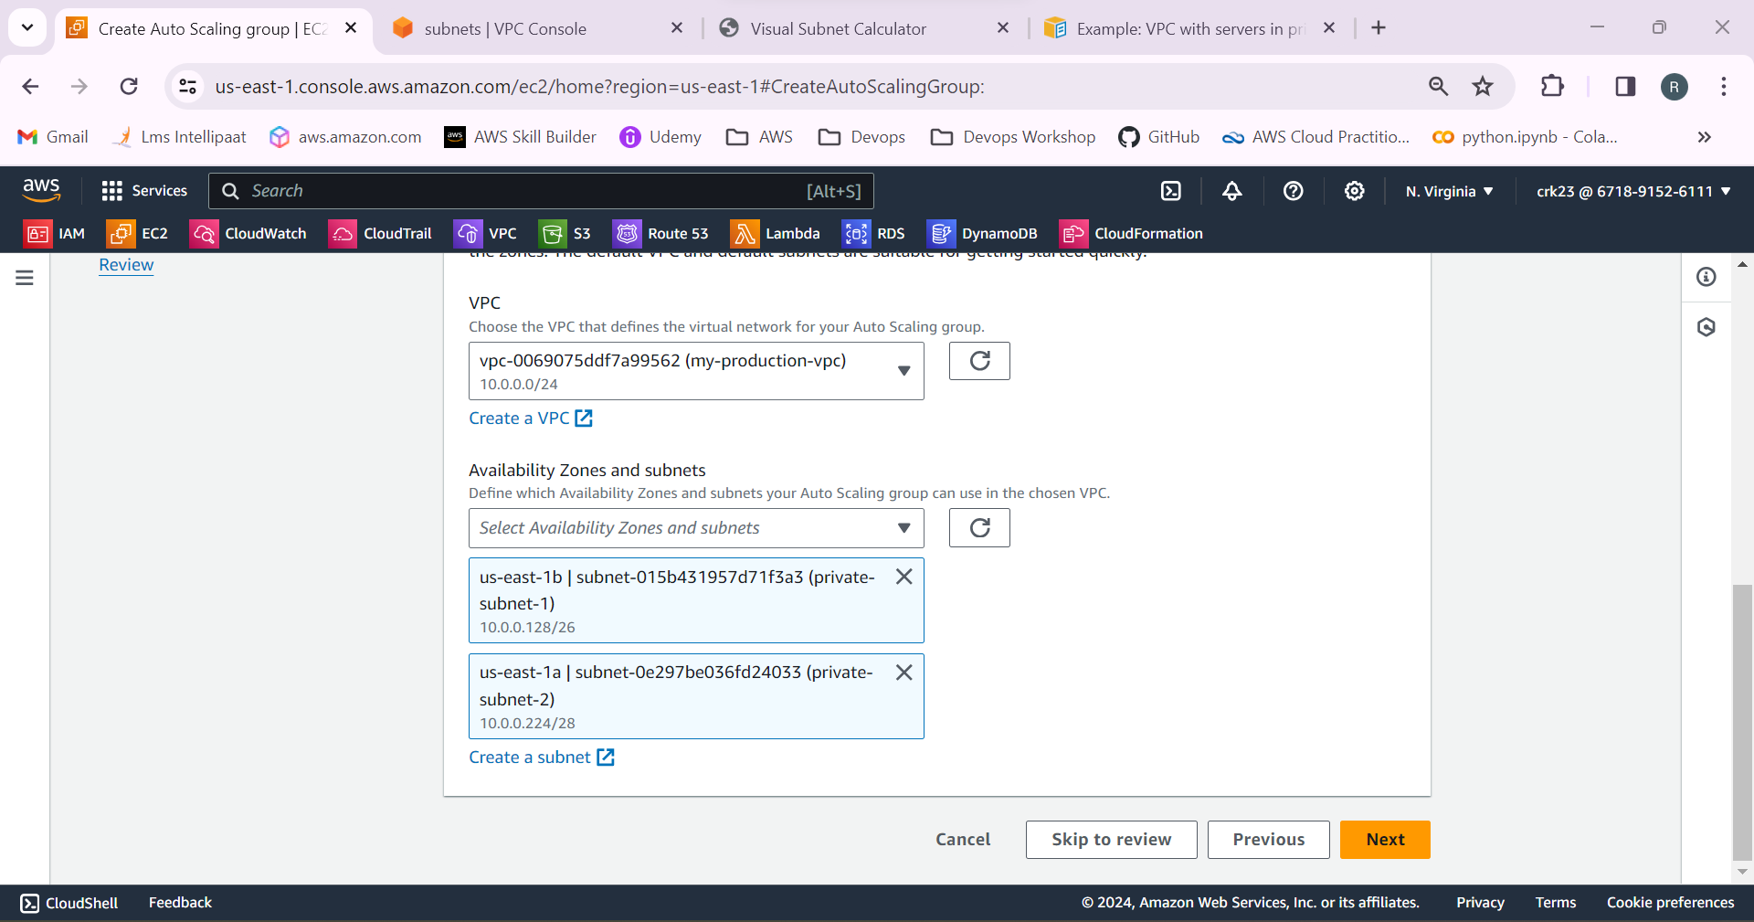

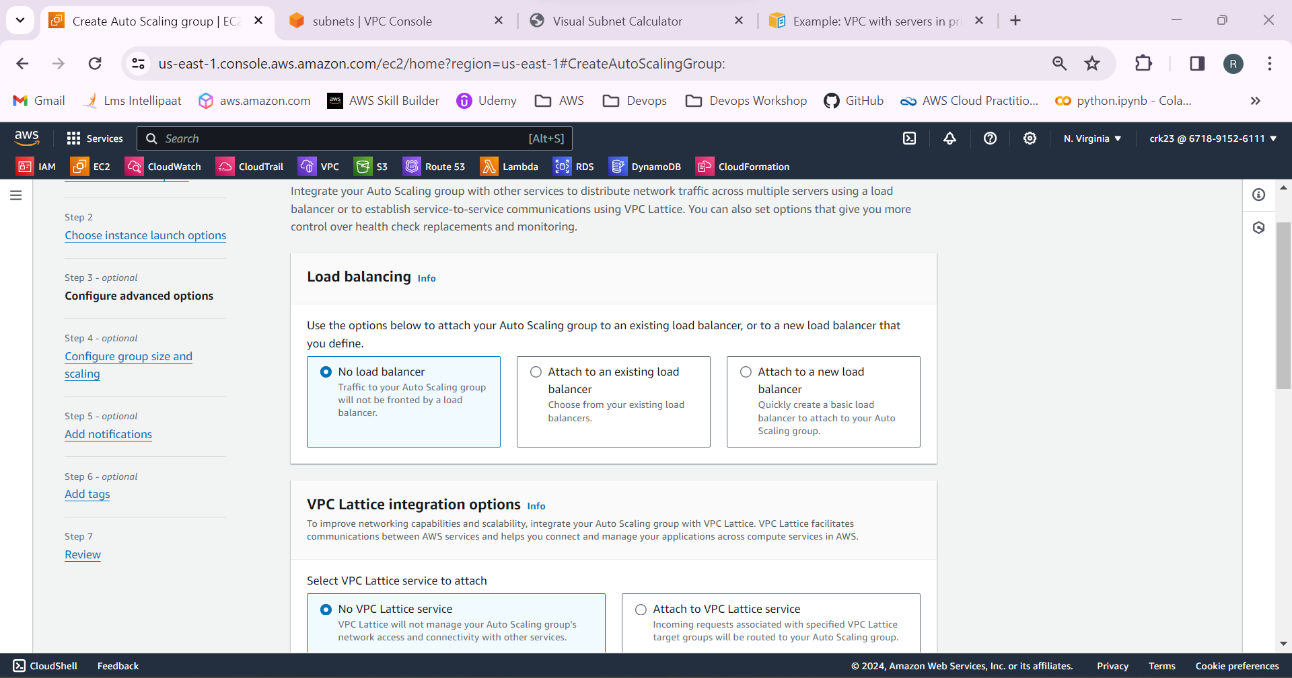

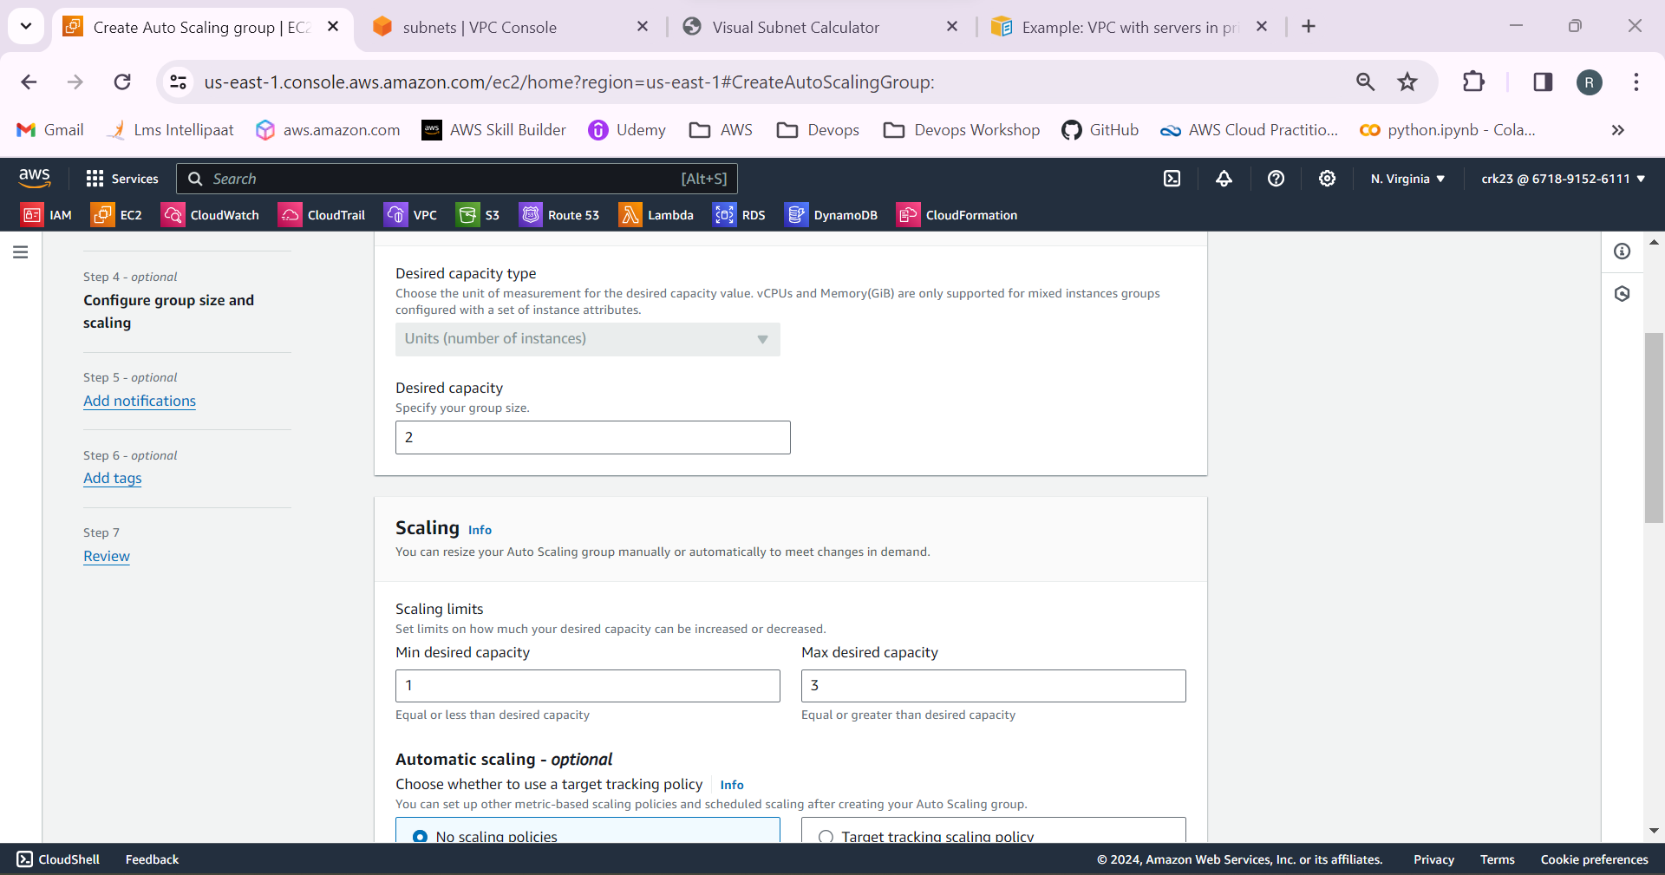

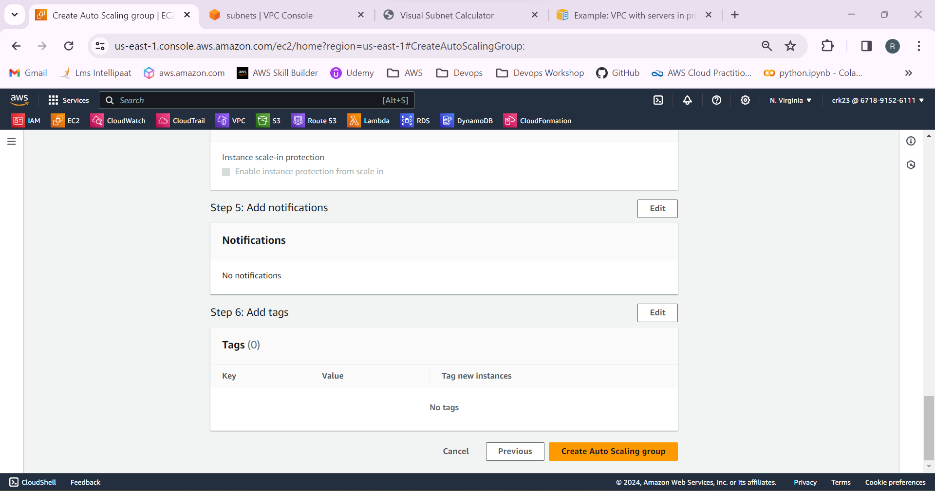

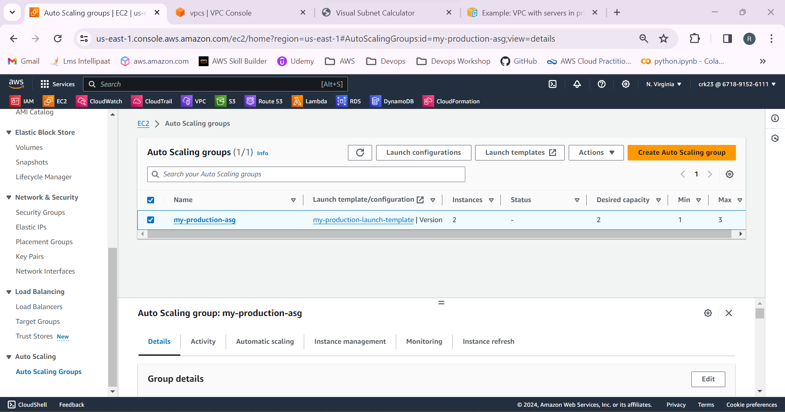

10.Now check the instances. Two instances has been launched in two availability zones.

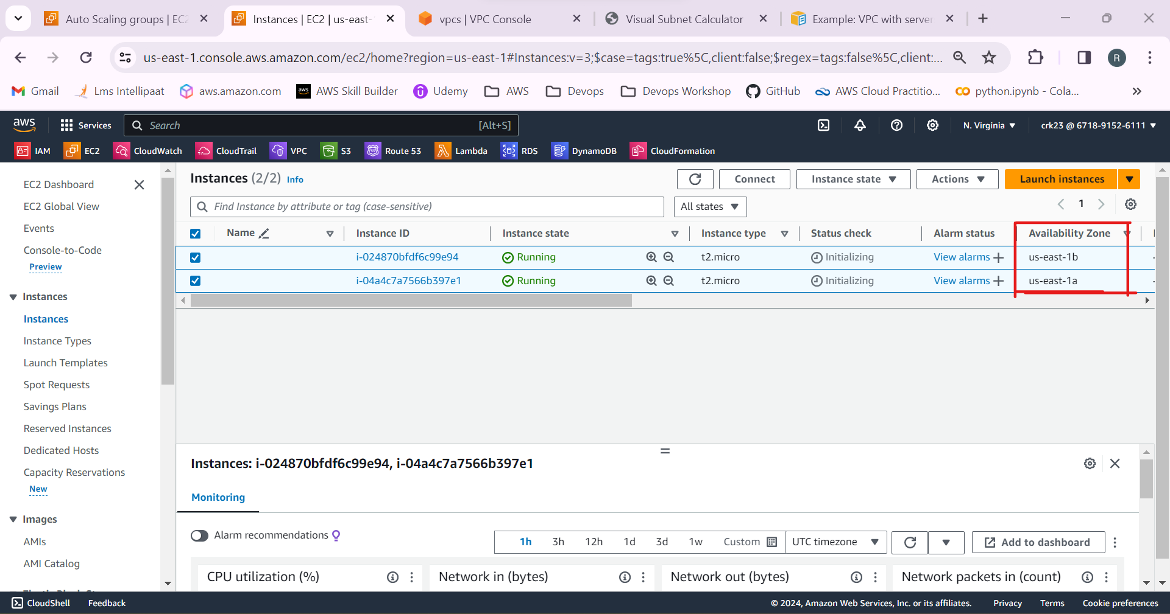

12.Create a jump server/bastion host. To connect to the servers in the private subnets using the jump server.

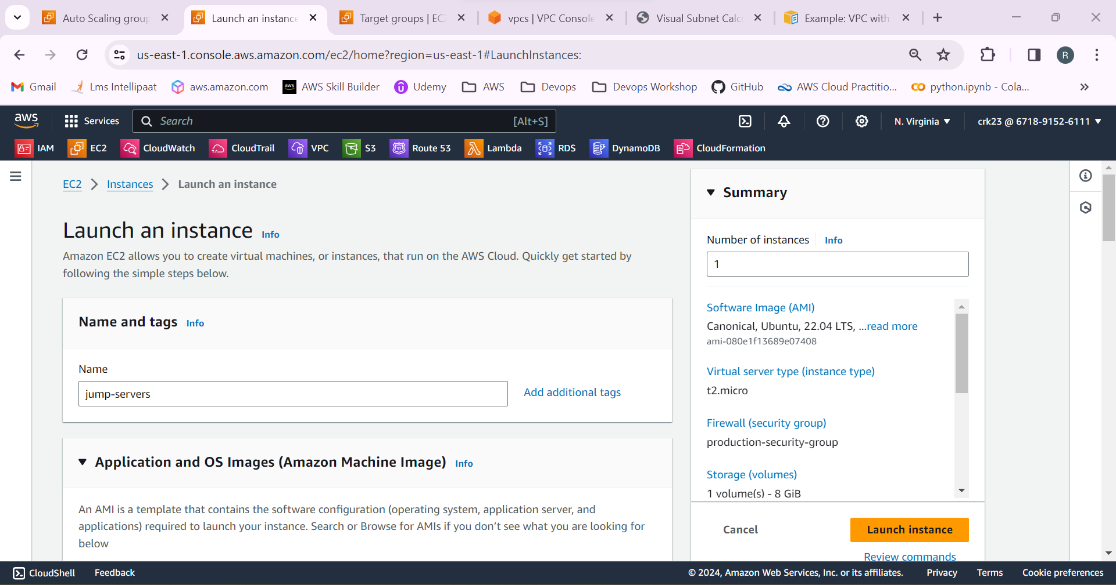

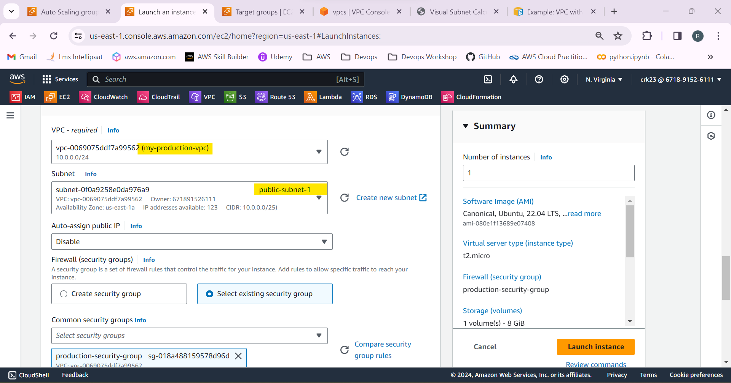

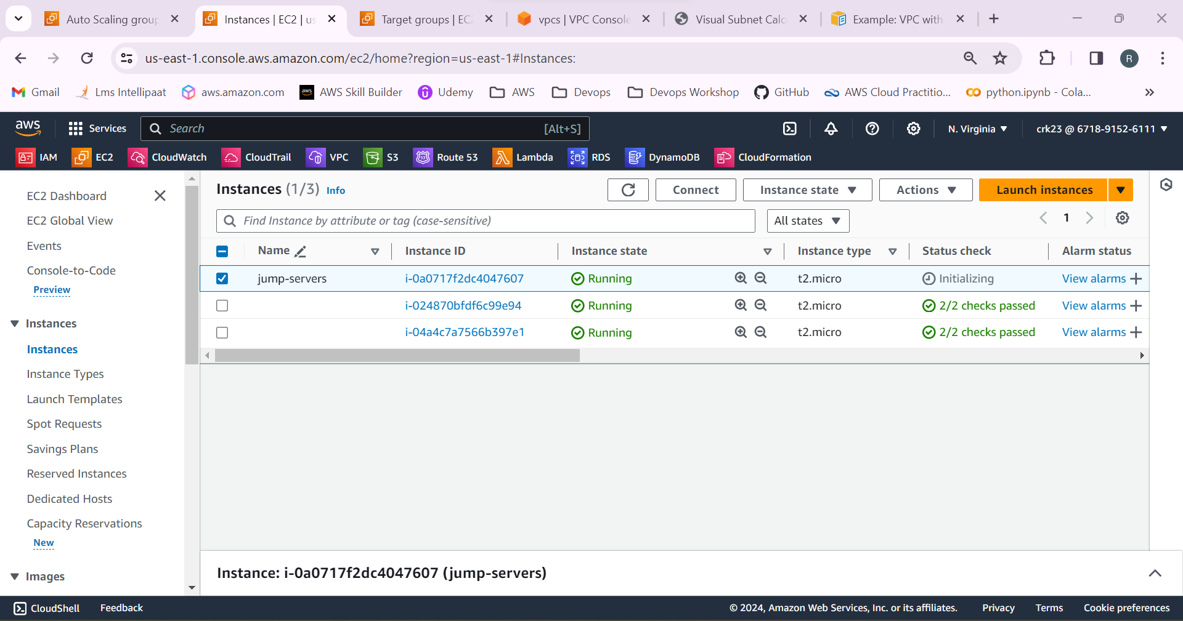

13.Open the terminal in our system. Use the command

**scp -i C:/Users/Ranjith/Downloads/neww.pem C:/Users/Ranjith/Downloads/neww.pem ubuntu@”ip-address”:/home/ubuntu**  to copy the key pair from local system location to the jump server location.

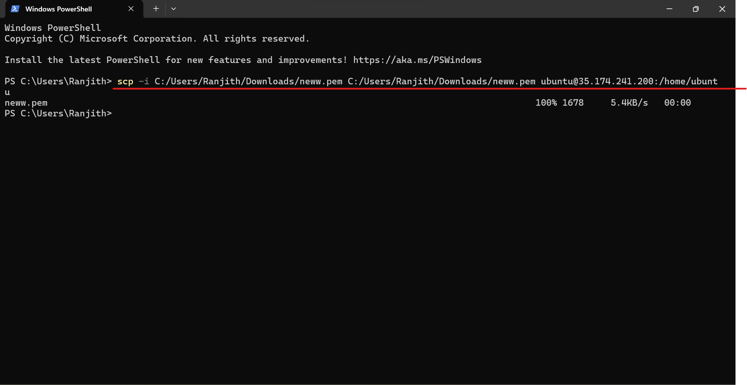

14.Login to the jump server using ssh -i “keypair name” ubuntu@”ipaddress”

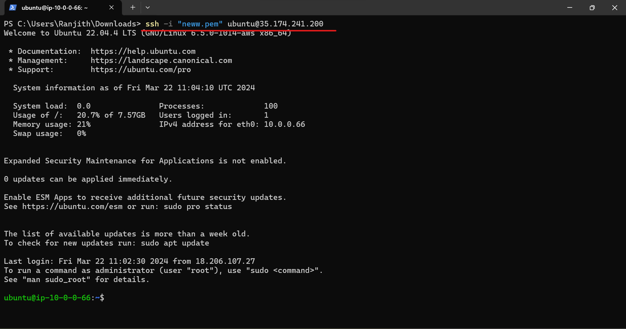

15.Keypair is copied to the jump server

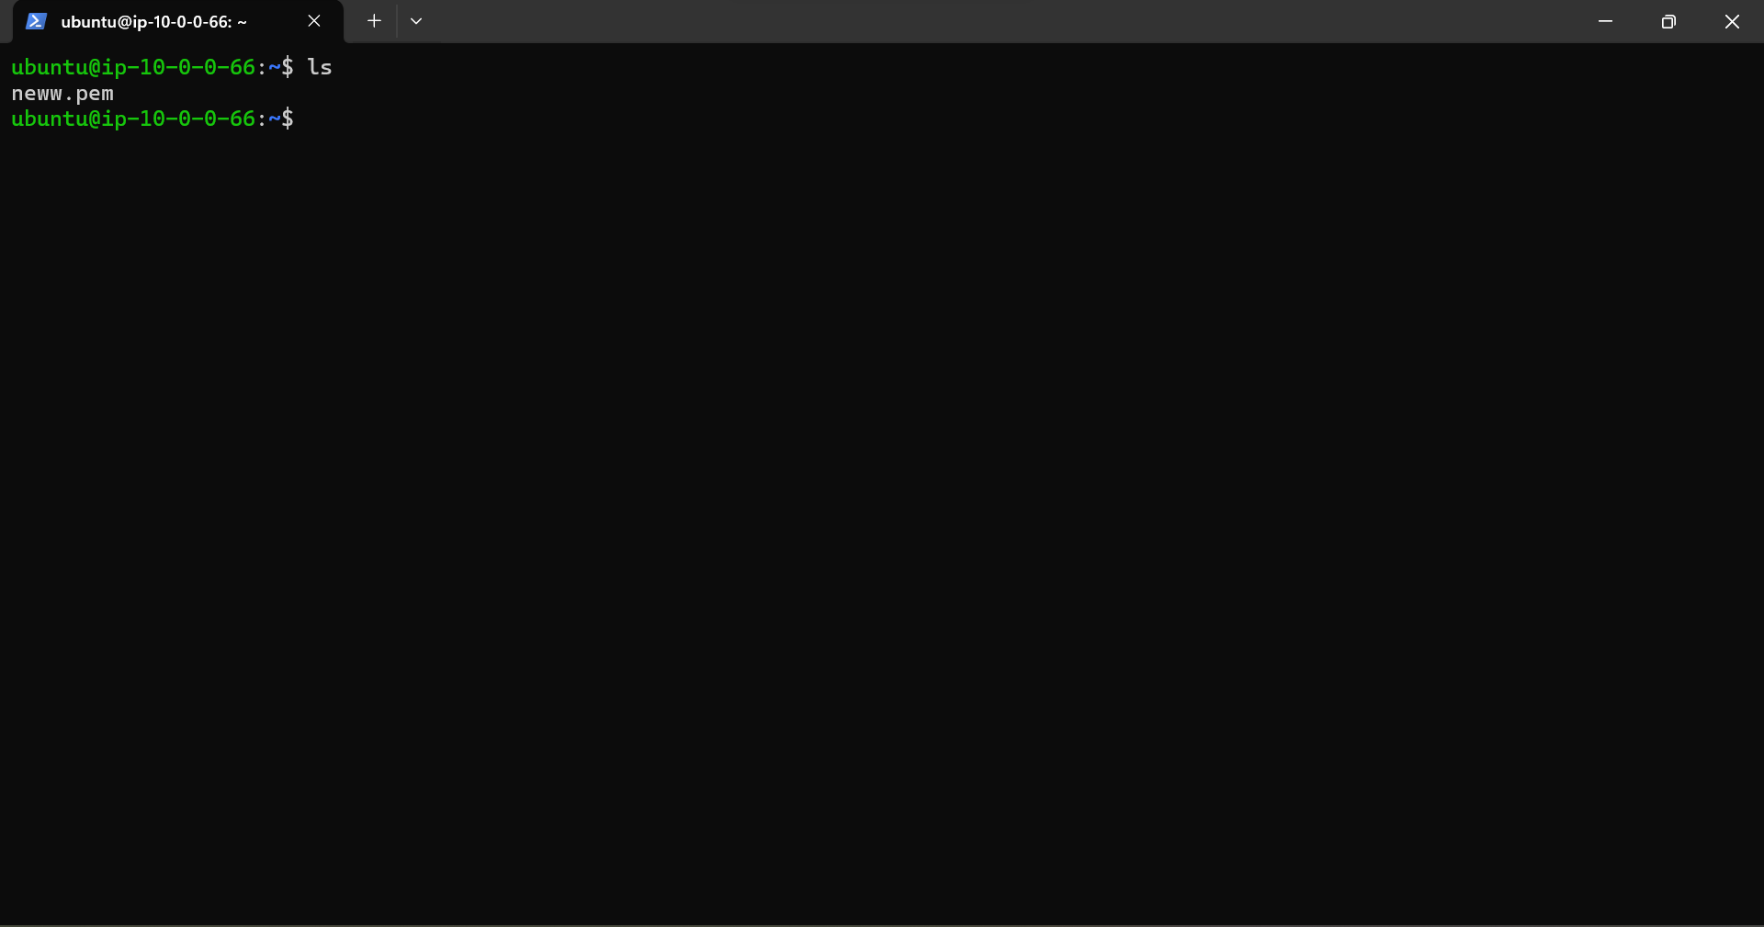

16.Copy the ip address of the private instance.

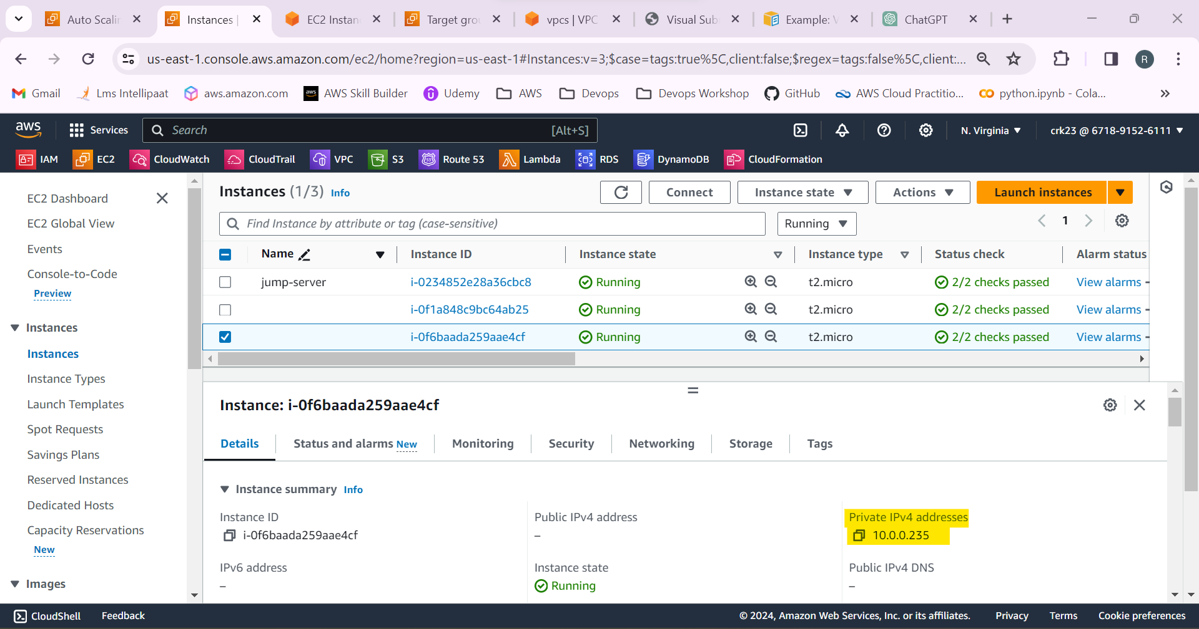

17.Login to the private instances through the jump server using ssh -I “keypair name” ubuntu@”ipaddress”

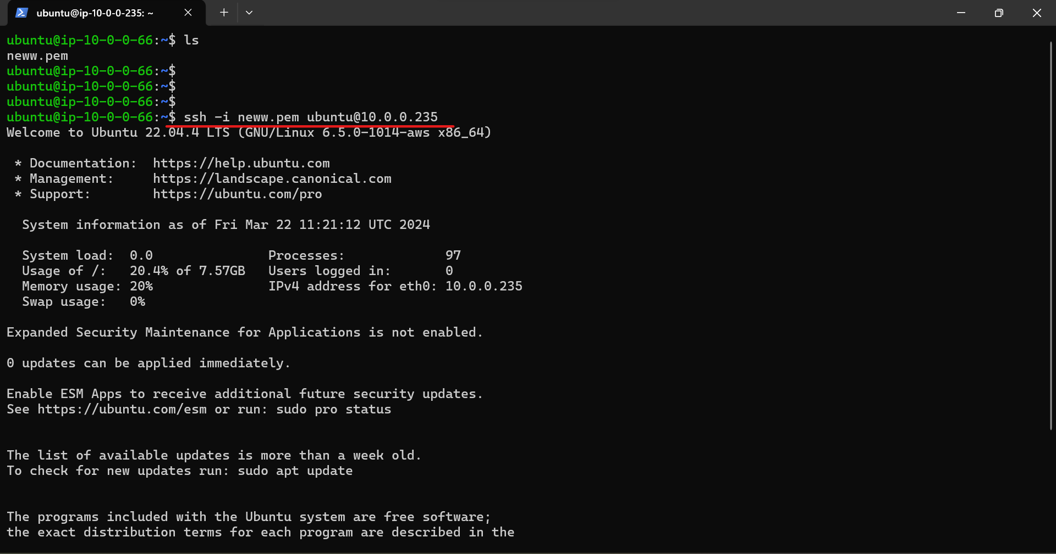

Login Successful!

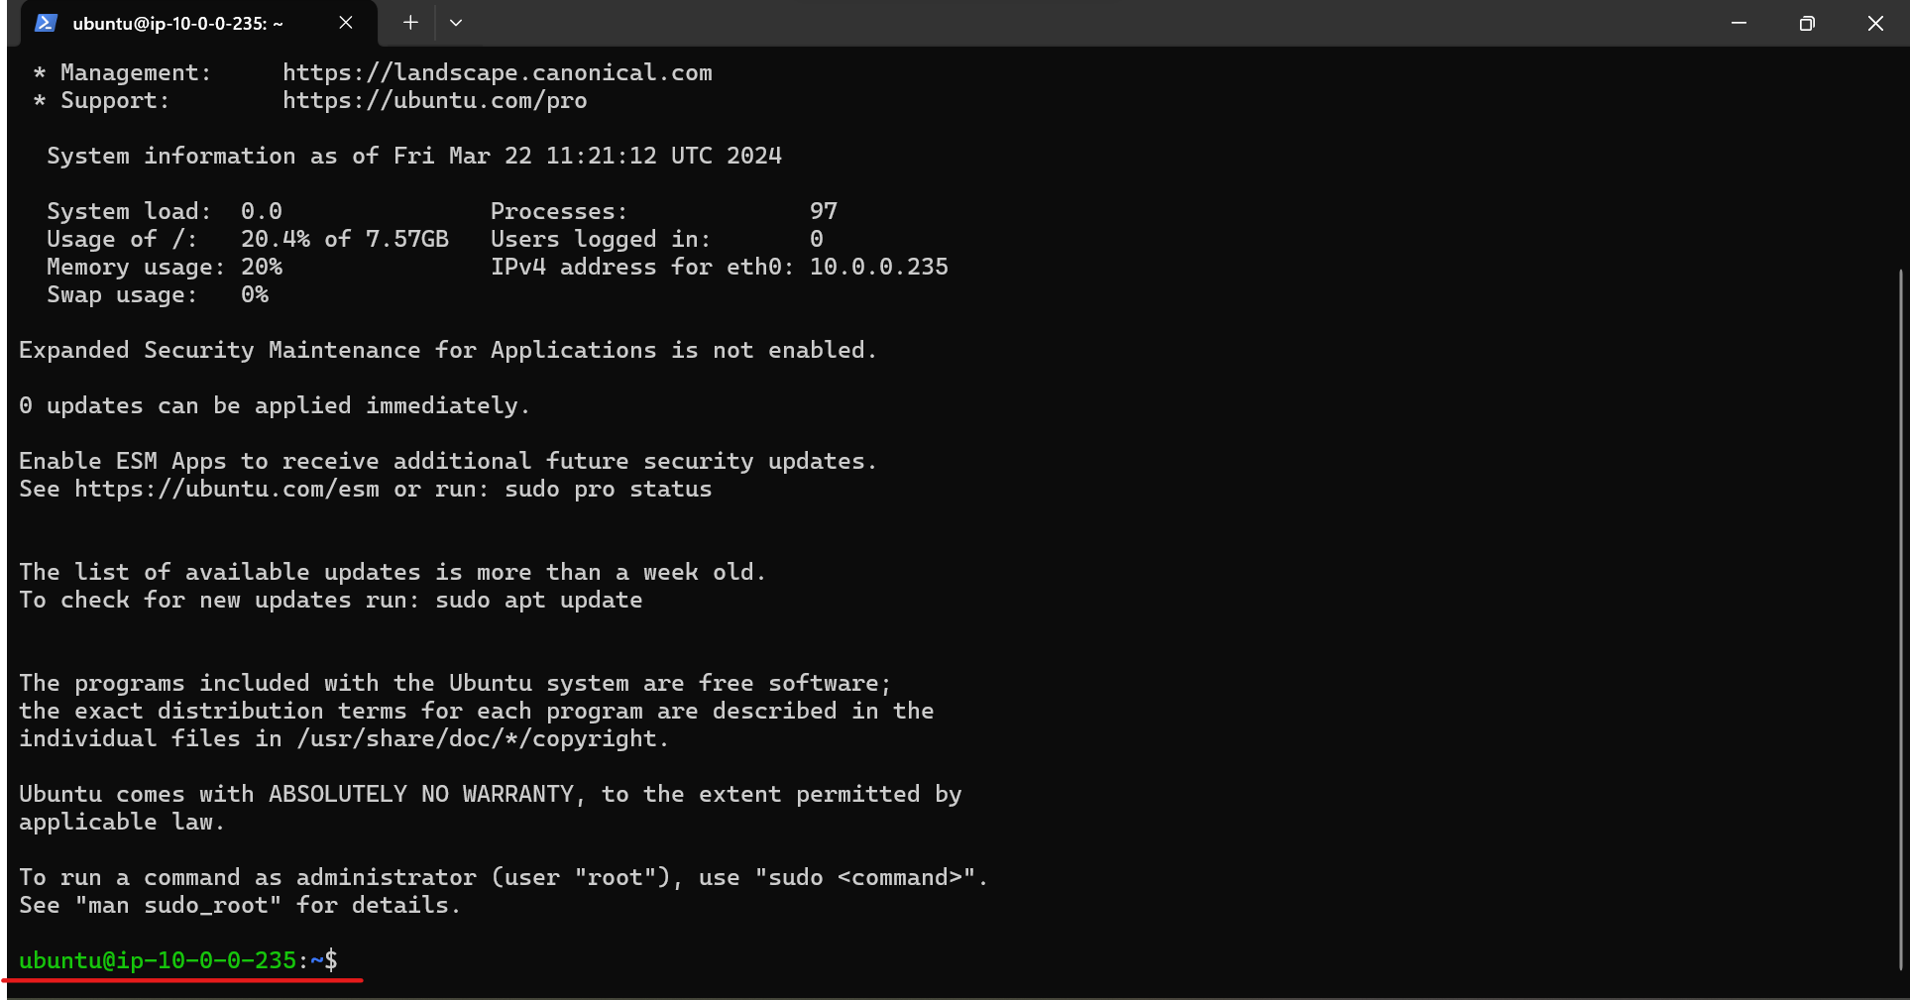

18.Create a index.html file and add a html code.

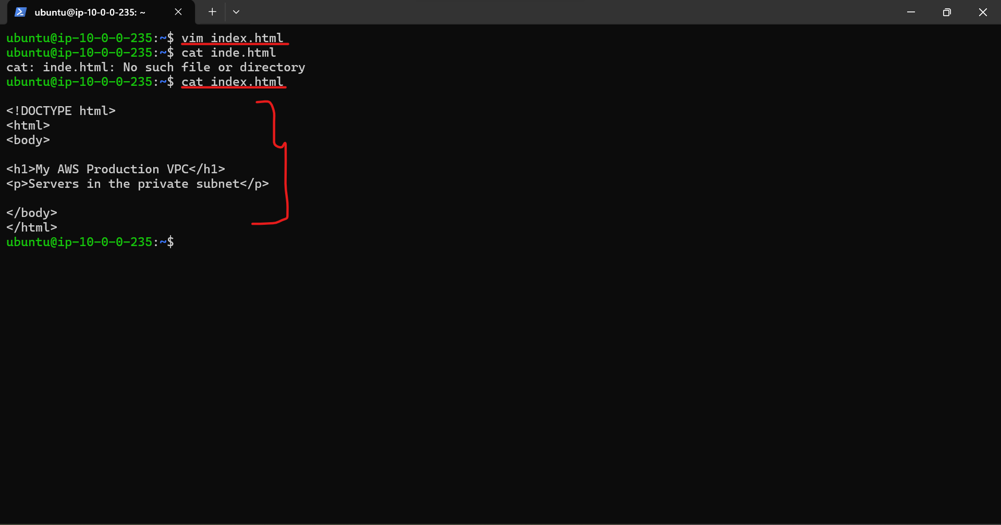

19.Use the command **python3 -m http.server 8000** to start a simple html server in python3.It serves files from the current directory over HTTP on port 8000. Port:8000 is allowed in the security group of the instances and the target groups of the load balancer.

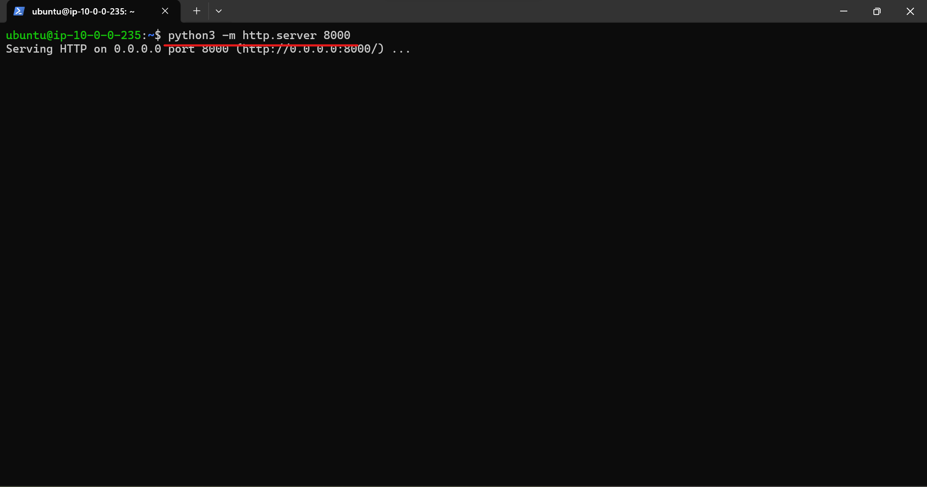

20.Create an Application Load Balancer

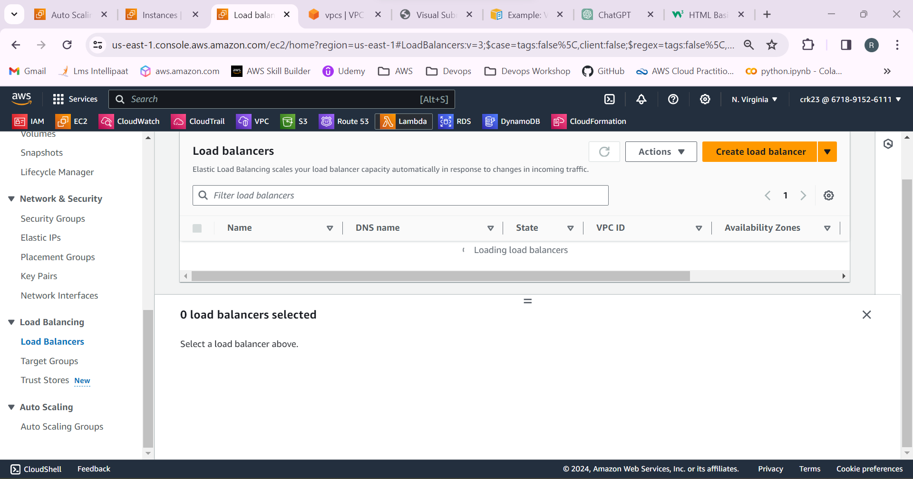

21.Before creating the Load balancer create the target groups.

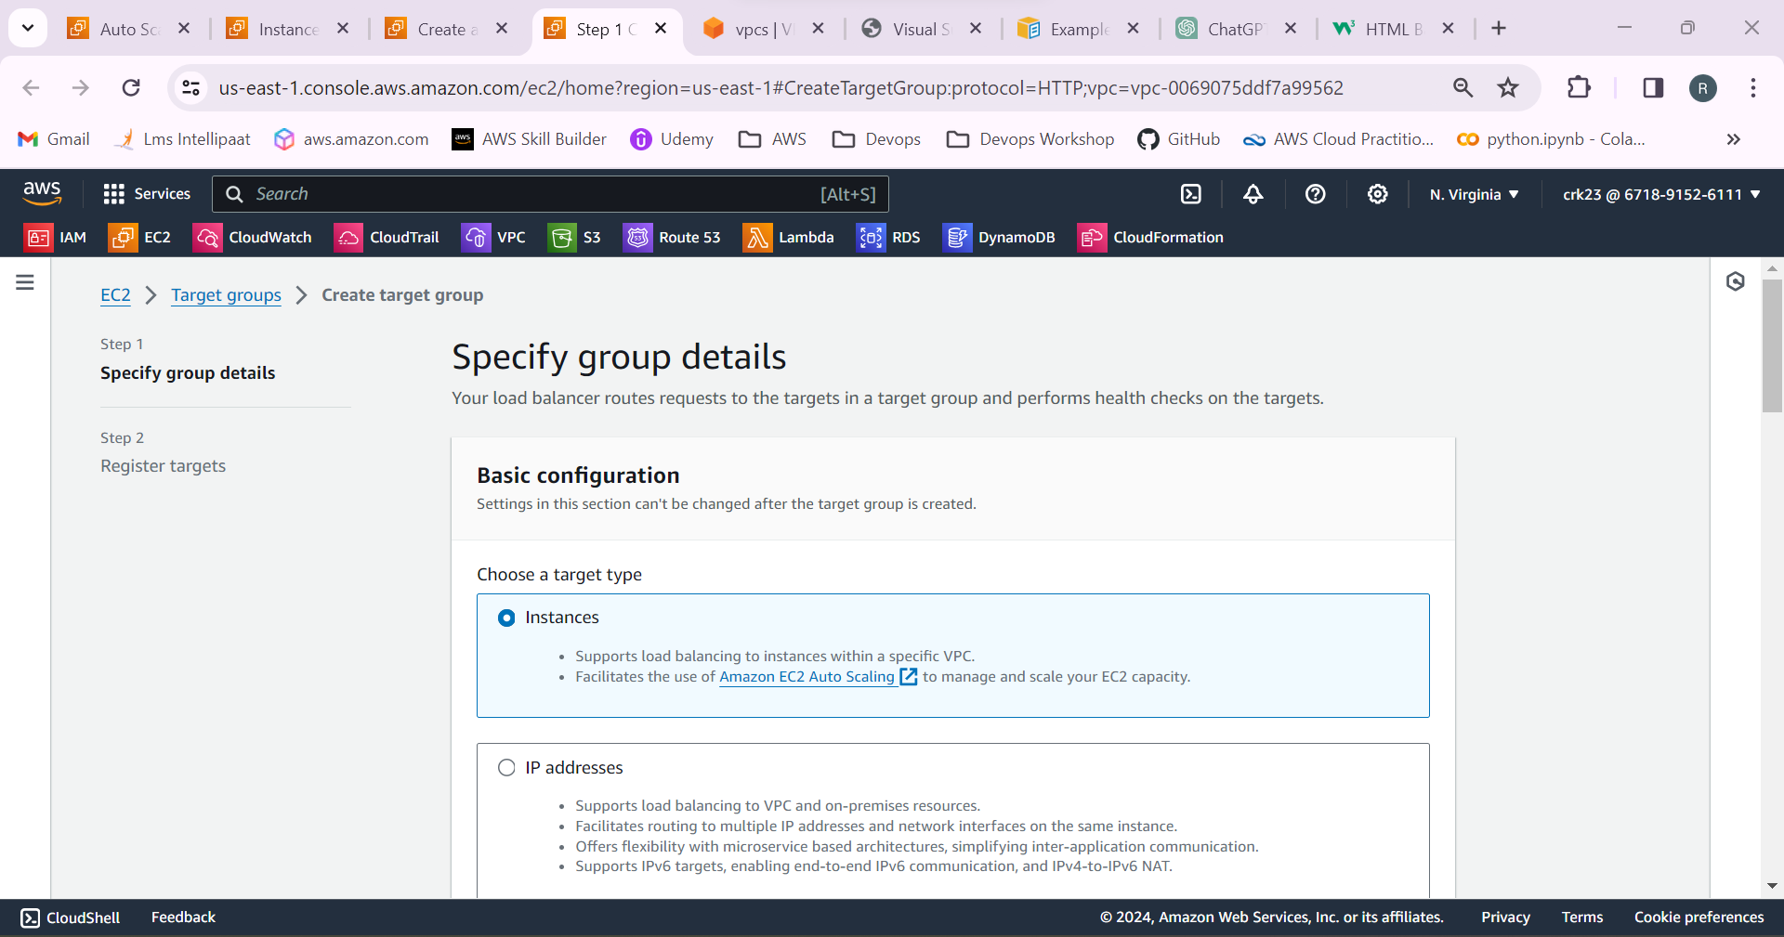

22.Add the two instances created by the auto scaling groups to the target groups.

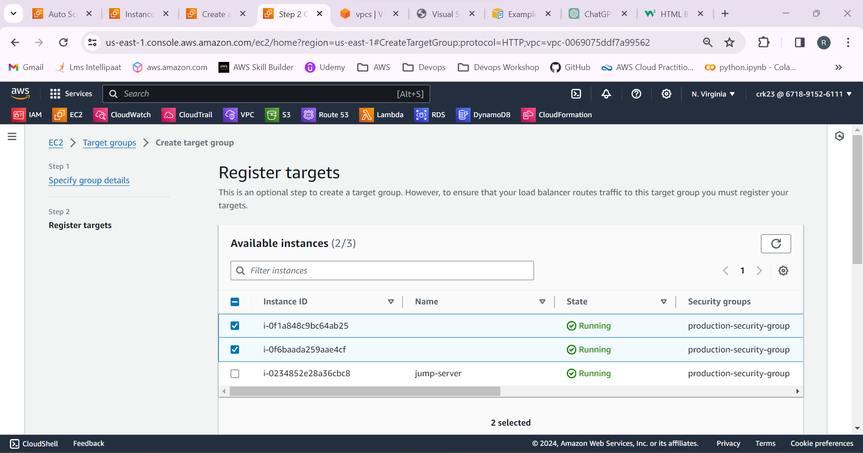

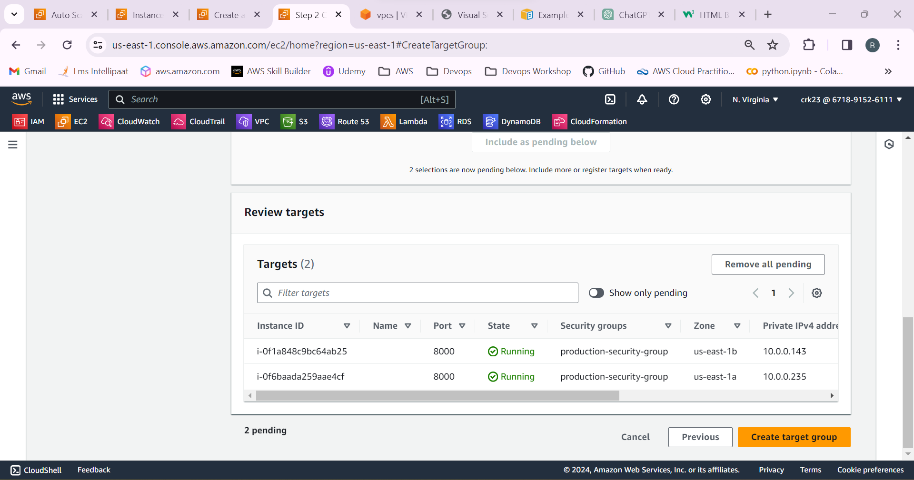

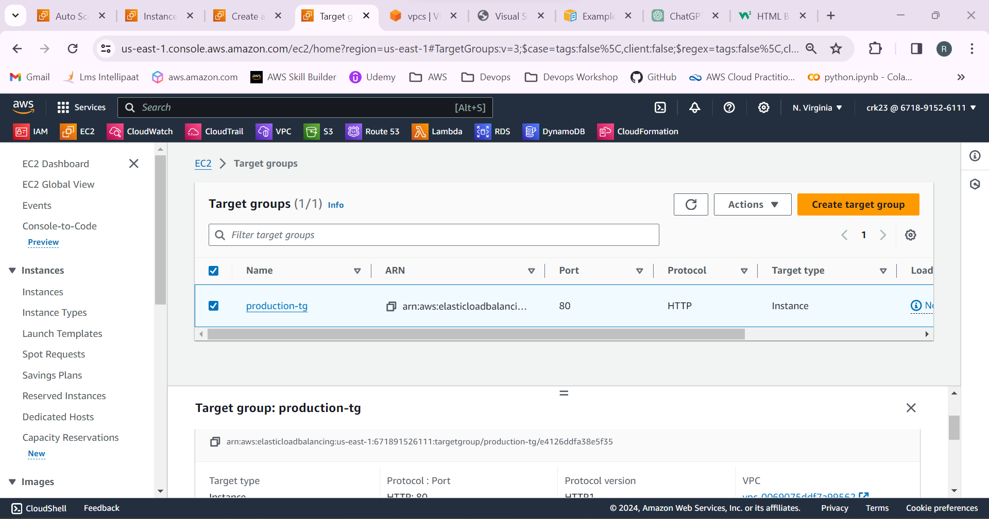

Select application load balancer.

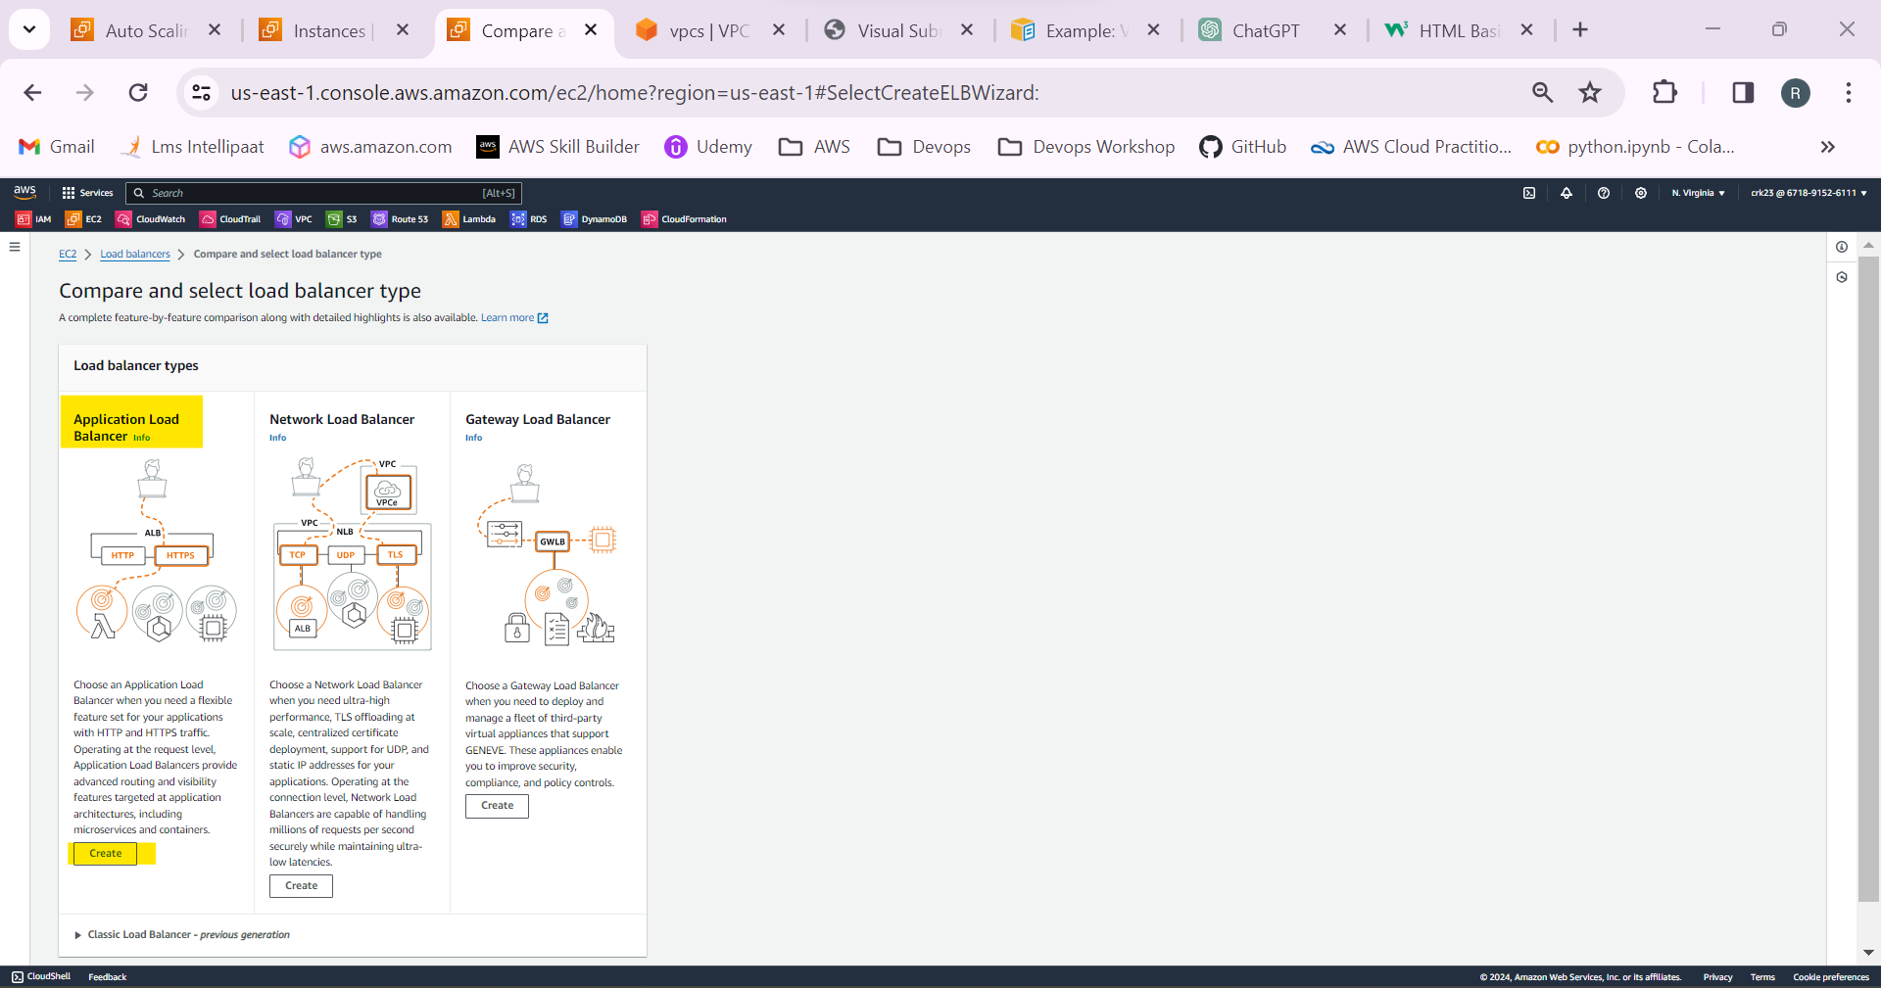

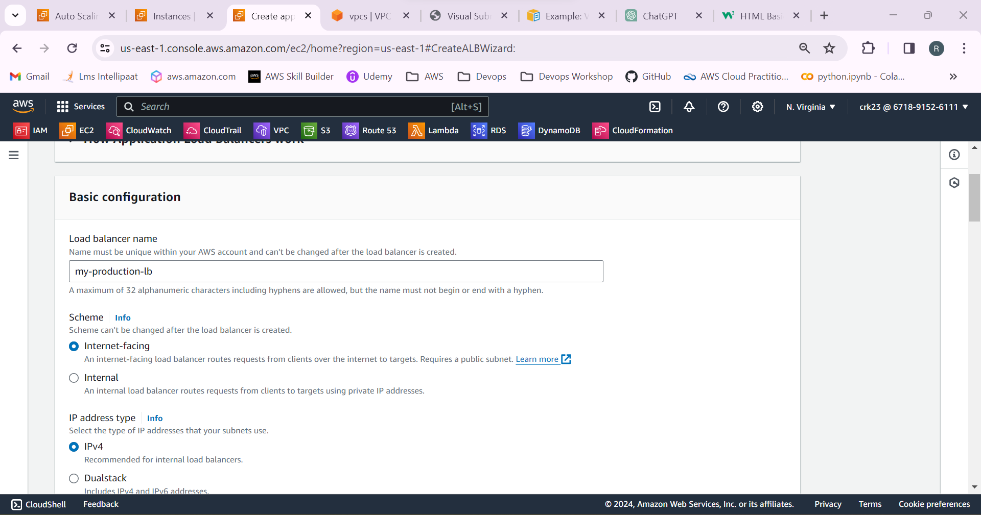

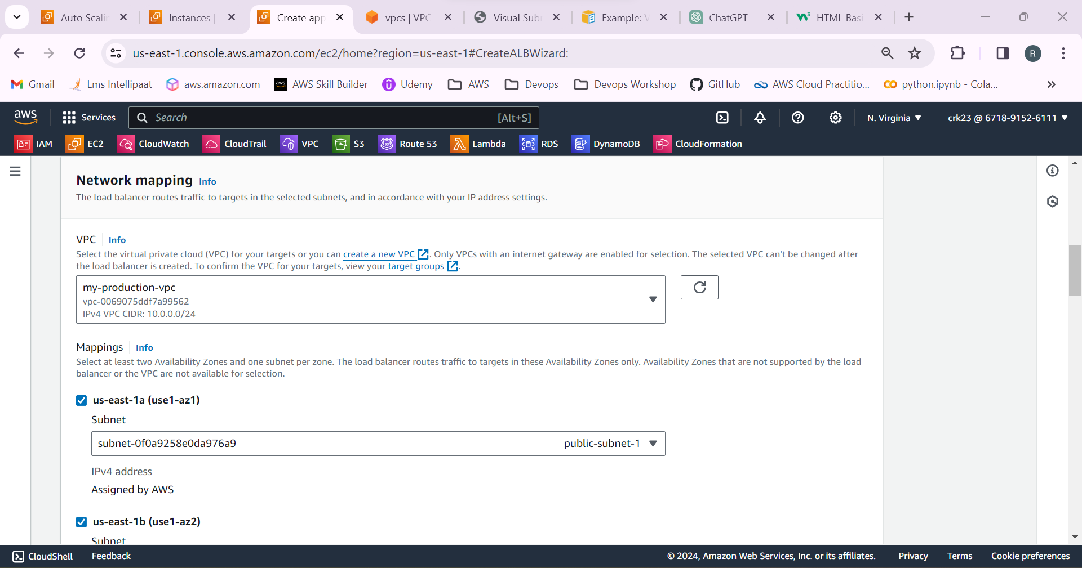

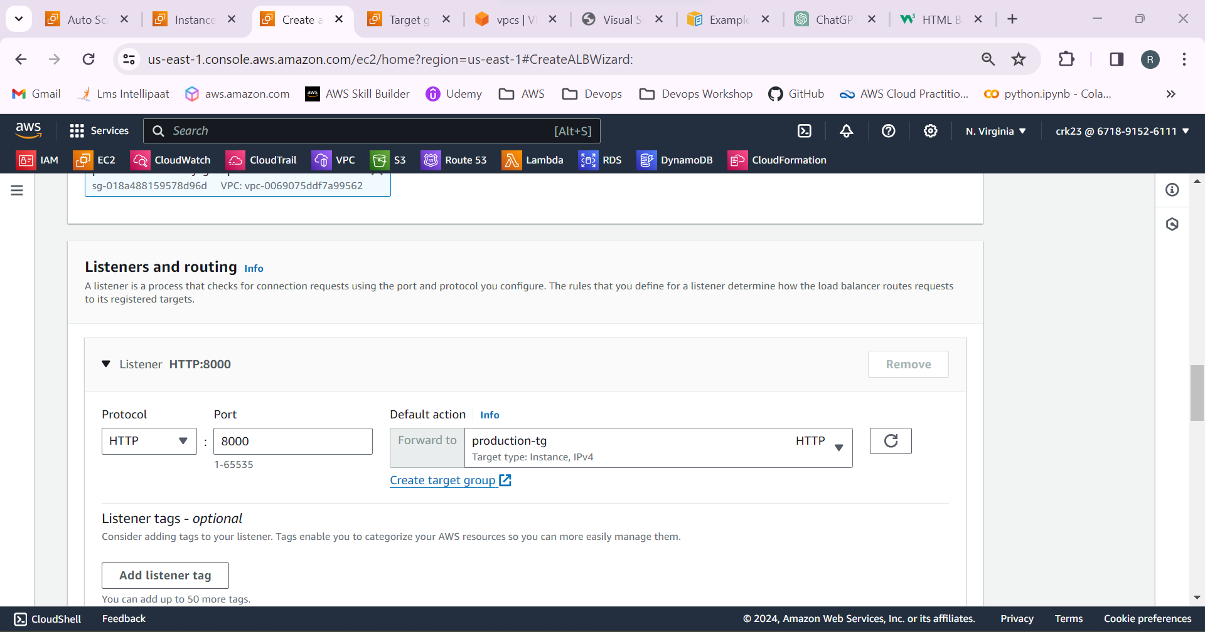

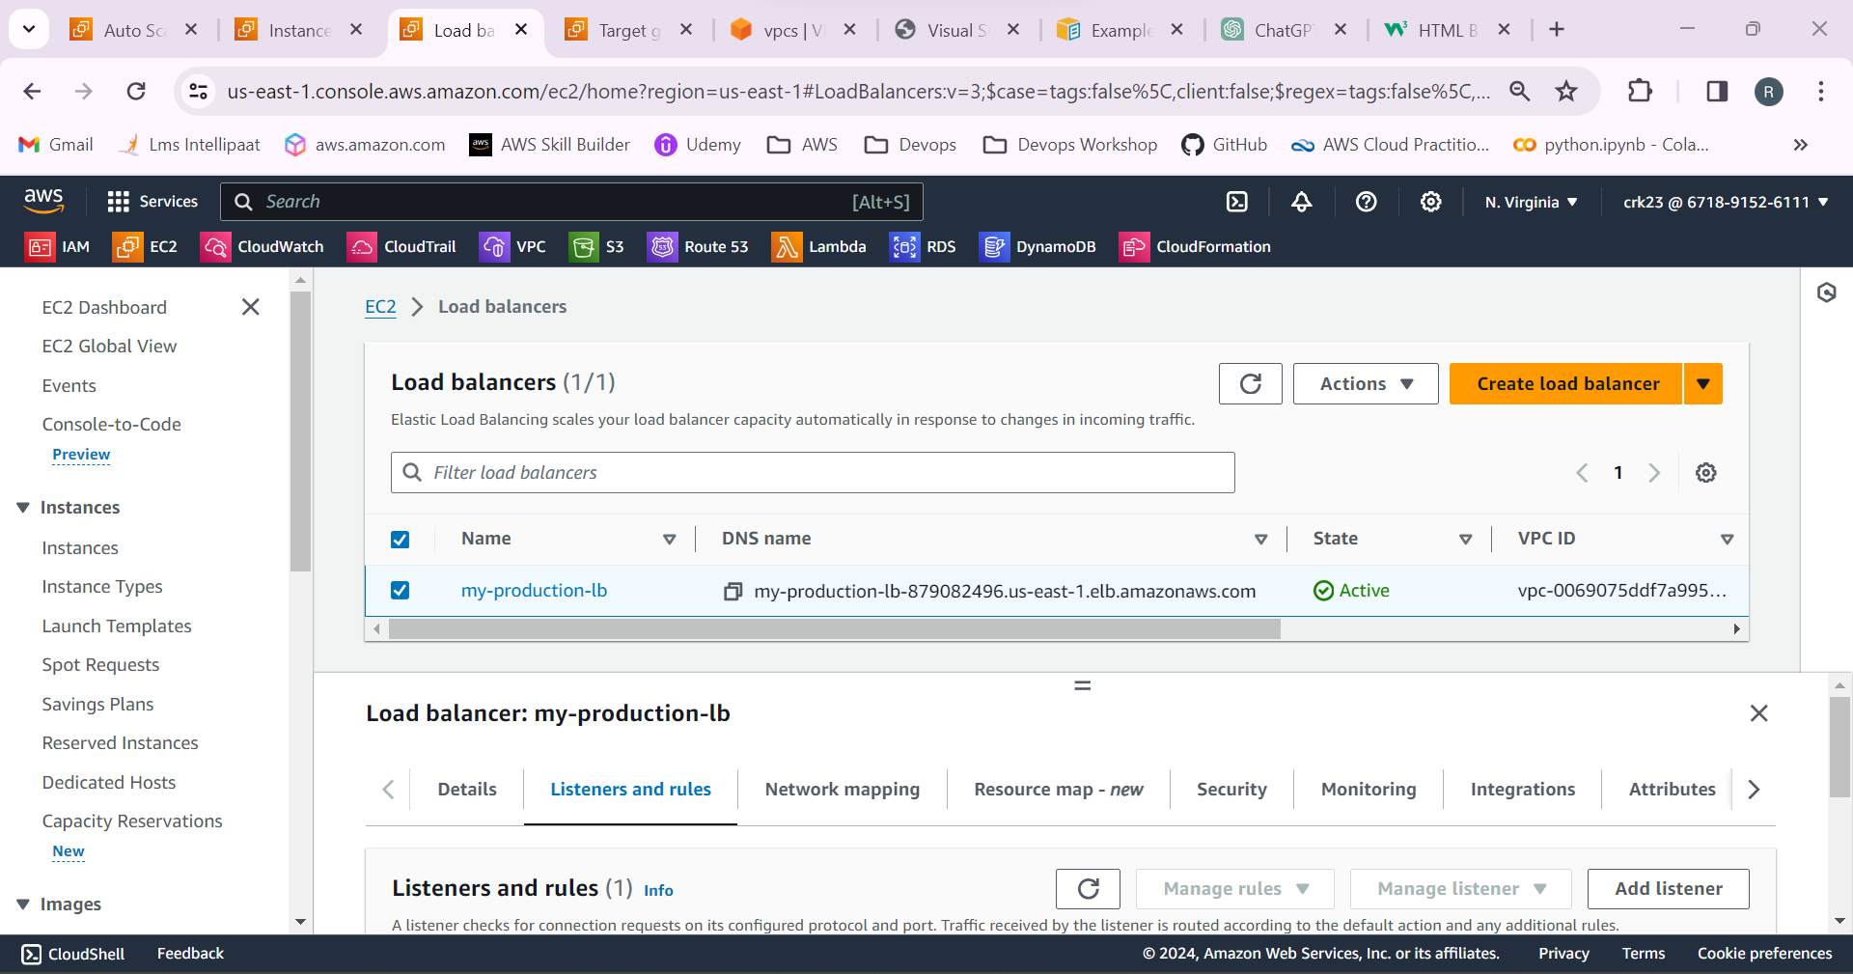

23.Copy the DNS name of the load balancer and paste it in the browser.

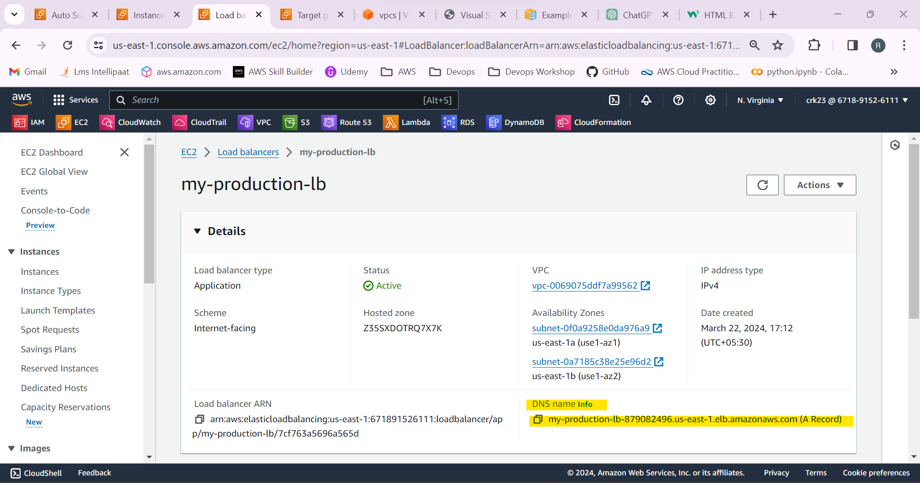

24.It’s Working. We can able to access the server through the load balancer.

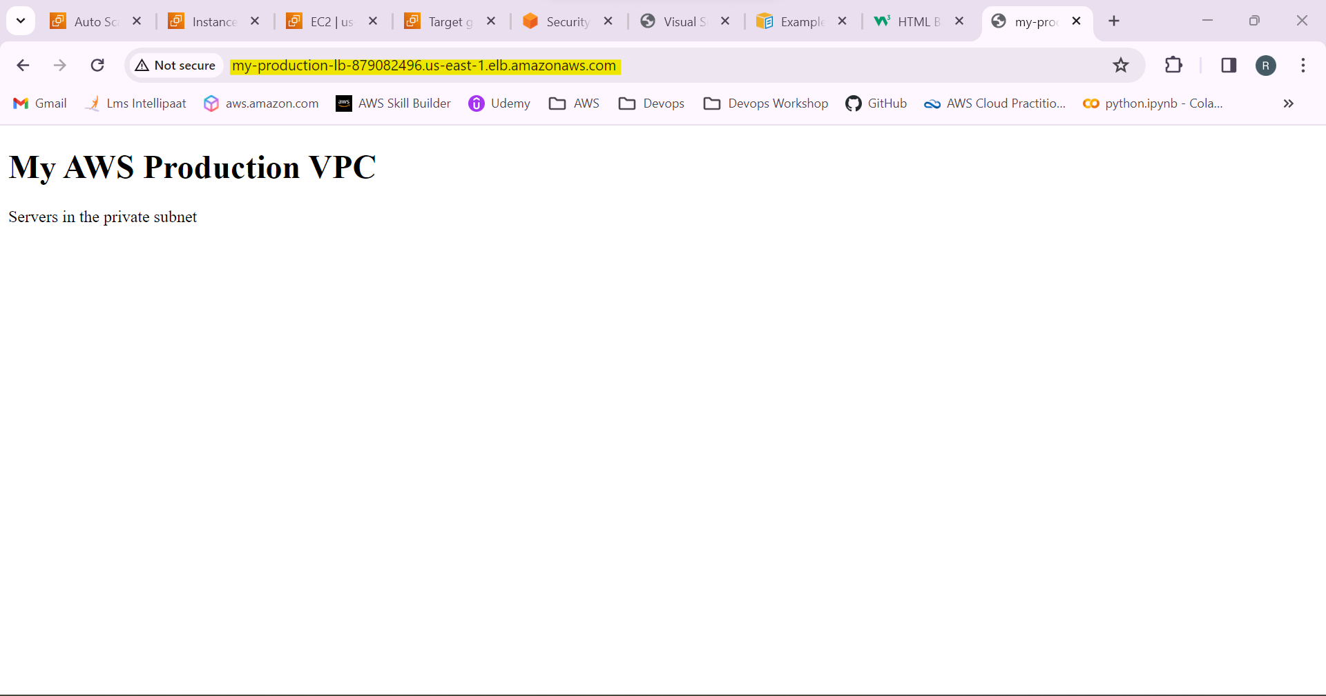

25.Previously html created only in the one server to see the difference between the targets. Now I have created a index.html file in other instance and started the http server.Now the load balancer started equally distributing the network load between the targets.

